CUTTING EDGE
Claude Flight and the Linocut Revolution

For my daughters

Copyright © 2026 by Anthony West
All rights reserved.
No part of this publication may be reproduced, stored in a retrieval system, or transmitted in any form or by any means — electronic, mechanical, photocopying, recording, or otherwise — without the prior written permission of the author, except for brief quotations used in reviews, criticism, or other non-commercial uses permitted by copyright law.

First Edition. Published by West Art Press
Kington, United Kingdom
Cover design by Anthony West
Author photograph by Anthony West
For information, updates, and future projects, visit:
West Press
 https://westpress.art
Many of the illustrations in this book will have a QR code that directs you to a web page giving more detail and in color if applicable.

CHAPTER 1: BEFORE THE CUT
The Formative Years of Claude Flight (1881-1914)
The story of Claude Flight's revolutionary transformation of linocut from humble decorative medium to fine art begins not with linoleum at all, but with his early life in late Victorian England—a time when strict hierarchies governed not just society but art itself, with certain mediums considered inherently superior to others.
Claude Percival Flight was born on August 10, 1881, in London during the height of Britain's imperial confidence. His father, Lionel Flight, was a successful businessman with connections to London's commercial and financial circles. His mother, Adelaide, came from a family with cultural pretensions and artistic inclinations. This background—comfortable but not extravagantly wealthy, respectable but not aristocratic—would shape Flight's relationship to art and society throughout his life.
The England of Flight's childhood was a nation undergoing profound transformation. The Industrial Revolution had reshaped the landscape and social structure. Queen Victoria reigned secure in her elderly years. London was the world's largest city and capital of the world's largest empire. Yet beneath the surface confidence, intellectual currents were shifting. New scientific theories challenged traditional beliefs. Artistic movements from Europe were beginning to question established academic traditions.

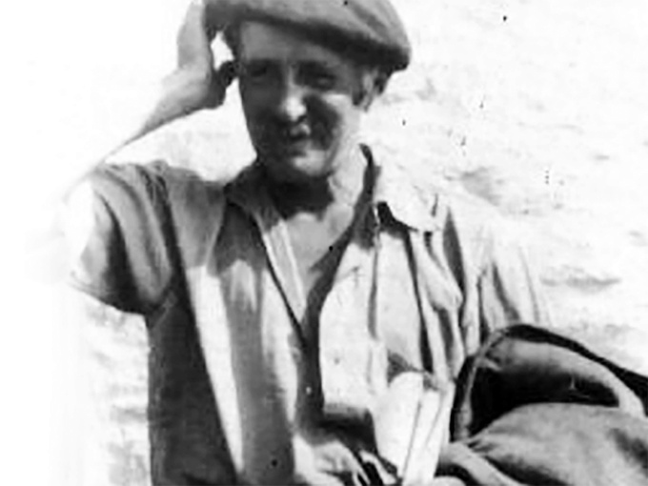  https://westpress.art/go/T
Claude Flight

Flight's early education followed conventional upper-middle-class patterns. He attended respectable schools where drawing and art appreciation were considered appropriate accomplishments for gentlemen—pleasant pursuits, certainly, but not serious professions. The actual practice of art was generally viewed as either the province of craftspeople and commercial workers, or as an aristocratic amusement for those with leisure and inherited wealth.
His artistic inclinations emerged early. Family accounts describe young Claude as devoted to drawing and painting, showing particular aptitude from childhood. By his teenage years, it was clear he had genuine talent and serious interest. The question that arose—debated within the Flight family and throughout Victorian society—was whether this interest should be encouraged toward professional artistic practice or treated as a refined accomplishment to be balanced with more respectable pursuits.
Training in Conventional Art
By the 1890s, when Flight was approaching adulthood, the structure of artistic training in Britain was well-established. The Royal Academy, founded in 1768, dominated the establishment art world. Its Royal Academy Schools provided rigorous academic training emphasizing classical principles: drawing from plaster casts and live models, study of the Old Masters, instruction in "proper" composition and perspective.
This academic tradition valued above all else the creation of unique, hand-made paintings in oil or watercolor, ideally depicting historical or mythological subjects, landscape, or portraiture. This was "fine art," the category that conferred prestige and commanded high prices. Everything else—prints, commercial illustration, decorative design, craft—ranked hierarchically below, considered secondary or inferior.

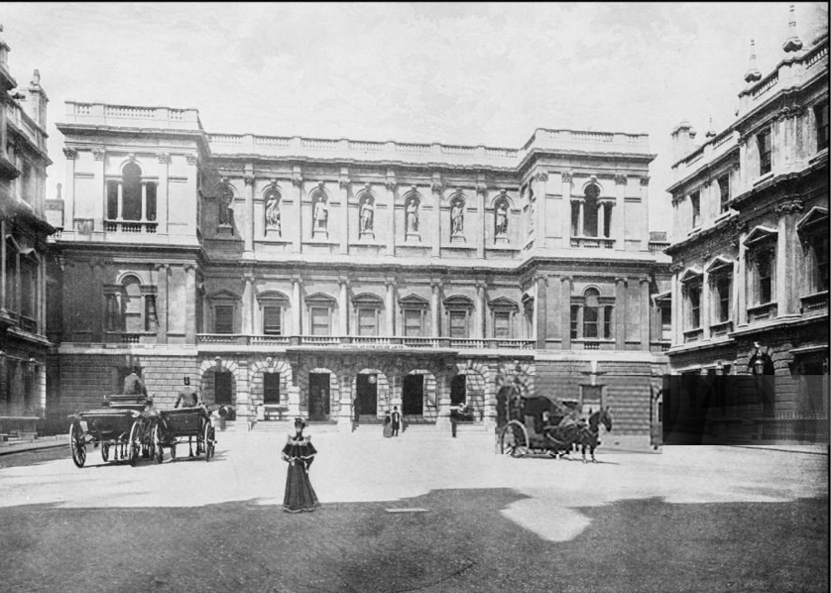
View of the Royal Academy, London, c. 1890s
Flight received his artistic training within this system. As a young man in the late 1890s, he studied at the Royal Academy Schools, absorbing the academic principles and perspectives that dominated British art education. He learned to draw with precision, to understand anatomy and proportion, to compose complex multi-figure compositions following classical principles.
The teaching was rigorous and in many ways excellent. The Royal Academy instructors knew their craft. Students who persevered developed real technical skill. Flight's academic training gave him a solid foundation in fundamental artistic principles. He could draw the human figure with accuracy. He understood composition and spatial relationships. He mastered the technical requirements of oil painting and watercolor.
Yet this very rigor and conventionality meant that the Royal Academy embodied what would increasingly come to seem like artistic conservatism. The institution celebrated the Old Masters and classical principles at precisely the moment when European art was beginning to break radically with those traditions. The academic system, for all its technical excellence, discouraged innovation and experimentation with new forms. It valorized tradition above originality.
The Artistic Landscape of Early Twentieth-Century Britain
By 1900, as Flight completed his academic training, the art world was in ferment—though the ferment was far more pronounced on the Continent than in Britain. In Paris, Cubism was gestating. Futurism would soon emerge from Italy. German Expressionism was developing its distinctive character. Russian artists were beginning to reimagine visual representation fundamentally.

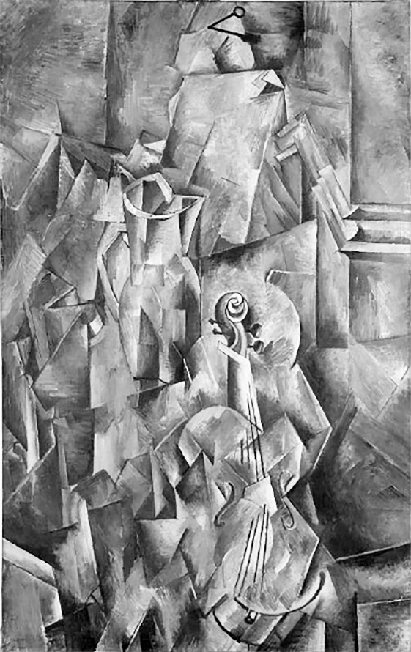  https://westpress.art/go/A1
Georges Braque: Pitcher and violin

Britain, by contrast, remained relatively conservative. The Royal Academy maintained its authority. Academic traditions persisted. The influential periodical The Studio promoted "modern" design but within relatively conventional boundaries. British collectors and museums looked to Continental developments but often with skepticism or several years' lag.
Yet younger British artists and intellectuals were beginning to look outward, to absorb influences from Paris and other European centers, to question whether academic tradition truly represented the future of art. This generational tension—between establishment conservatism and younger artists' desire for innovation—would define the early twentieth century in British art.
Flight's early career unfolded within this transitional moment. Like many ambitious young artists of his generation, he worked to establish himself professionally. He exhibited at various venues, painted in the academic tradition he had been taught, sought patrons and collectors. He was moderately successful—his work found appreciation, he received commissions, he could support himself through his art.
But this success within the academic system apparently left him unsatisfied. Contemporary accounts and his own later recollections suggest he felt constrained by academic conventions, suspicious of the hierarchy that elevated certain mediums while dismissing others, interested in finding new approaches to art-making that might feel more alive and contemporary.
Early Experiments and Growing Dissatisfaction
Through the first decade of the twentieth century, Flight's work evolved. He remained technically accomplished and academic in his approach, but increasingly engaged with more contemporary subjects and visual languages. He was not among Britain's most radical innovators—he was never a Vorticist or Futurist—but he was alert to new possibilities in artistic practice.

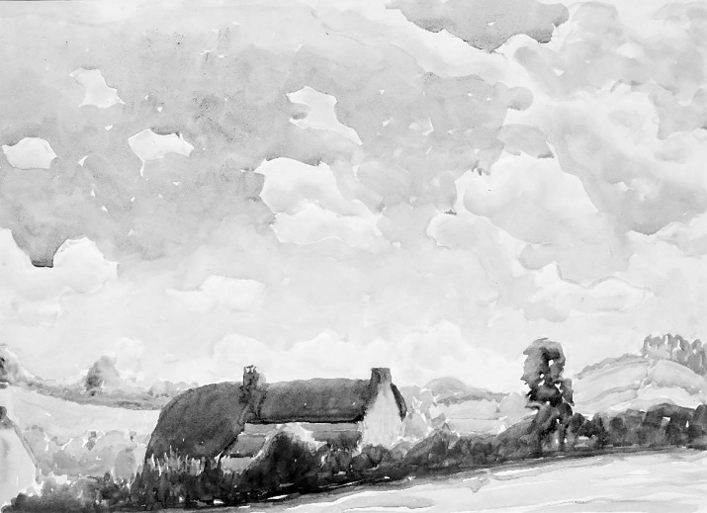 https://westpress.art/go/A2
Claude Flight, Rural Idyll,

Crucially, Flight's thinking about art was shaped by social and philosophical currents of his time. He was influenced by ideals of democratic culture and accessibility. The arts shouldn't be exclusive preserves of the wealthy and educated, he came to believe. Art should engage with contemporary life. It should be available to ordinary people, not just collectors and connoisseurs.
These beliefs were not unique to Flight—they were widespread among progressive thinkers in Britain in the early twentieth century. The Arts and Crafts movement, which had emerged in the later nineteenth century through figures like William Morris, had articulated a critique of industrial mass production and championed handcraft and authentic artistic labor. This movement influenced Flight's thinking profoundly, even though his ultimate innovations would differ significantly from Arts and Crafts principles.
The Arts and Crafts ideal celebrated individual craftsmanship and rejected industrial standardization. It assumed that artistic integrity was most fully realized in unique, handmade objects. This philosophy reshaped design, architecture, and craft practice throughout the late nineteenth and early twentieth centuries. But it also, inadvertently, reinforced hierarchies that privileged the unique, individually created artwork over mediums capable of multiple reproduction.
Flight began to question these assumptions. If art should be democratic and accessible, why should printmaking—which could produce multiple copies available at modest cost—be considered inferior to painting? Why should the capacity to create multiple impressions diminish an artwork's value?
These questions, radical in their implications, emerged from Flight's growing conviction that art hierarchies needed fundamental challenge. This philosophical position—that democratic accessibility and artistic excellence weren't opposed but could reinforce each other—would eventually lead him to linocut. But the path there required him first to move beyond academic painting and explore other mediums and approaches.
Meeting Contemporary Influences
Around 1910, as Flight approached thirty, he began engaging more directly with contemporary artistic developments. He was exposed to Japanese printmaking—particularly ukiyo-e woodblock prints—which were becoming increasingly available and studied in Europe. These prints demonstrated that multiple impressions, far from diminishing artistic merit, could showcase extraordinary sophistication of composition, color, and technical mastery.
Japanese printmakers created works of profound beauty and artistic consequence through the print medium. Their work challenged Western assumptions about the

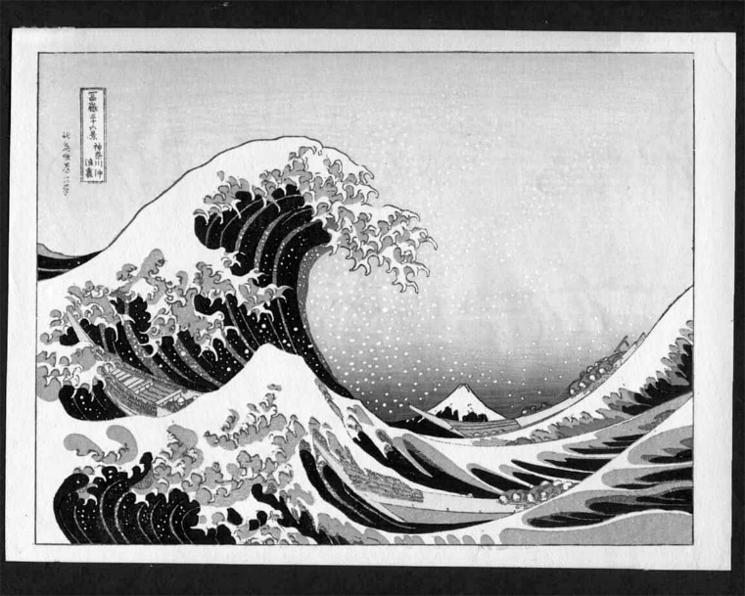 https://westpress.art/go/A3
Japanese ukiyo-e woodblock print

hierarchy of mediums. If Japanese masters had created undisputed masterpieces through woodblock printing, how could printmaking be categorically inferior?
This exposure to Japanese aesthetics opened Flight's thinking. He began to reconsider what constituted "serious" art. He became interested in graphic design and commercial art, recognizing that these supposedly "lesser" fields contained genuine aesthetic sophistication and technical innovation.
He also encountered through Continental artistic developments being discussed in London's progressive circles—ideas about modernism, abstraction, and the possibility of developing visual languages suited to contemporary life rather than academic tradition. The Cubist revolution of 1907 and its aftermath demonstrated that fundamental rethinking of perspective, form, and space was possible and artistically productive.
Flight didn't become a Cubist or radical modernist in the Continental sense. His temperament was too measured, his approach too pragmatic. But he absorbed the lesson that artistic tradition could be productively challenged, that new approaches were not only possible but artistically necessary.
Professional Consolidation and Growing Restlessness
By 1914, when World War I interrupted European culture and sent millions to the trenches, Flight was an established artist in his early thirties. He had exhibited regularly, supported himself through his art, been recognized as competent and professional. By conventional measures, he had achieved artistic success.
Yet something was missing, or so he came to feel. The academic tradition in which he had been trained seemed increasingly exhausted. Academic painting could display technical virtuosity but often felt empty of genuine innovation or contemporary relevance. The artistic life he had been prepared for seemed to offer a narrowing rather than an opening.
He was thinking increasingly about printmaking, about graphics, about how artistic communication might operate beyond the framework of unique paintings destined for wealthy collectors. He was reading and thinking about art theory. He was beginning to develop a more systematic philosophy of what art should be and do in the modern world.
The war years (1914-1918) interrupted these intellectual developments but also, paradoxically, crystallized them. War created intense cultural disruption and crisis. Millions died in the trenches. Society was fundamentally stressed. In this context, the genteel concerns of academic painting seemed not just exhausted but trivial.
When the war ended in 1918, Europe faced reconstruction. There was widespread desire to imagine new beginnings, new possibilities, new ways of organizing society and culture. It was in this post-war moment, with the old certainties shattered, that Flight began to seriously explore alternatives to academic art practice.
He was now in his late thirties, with decades of professional artistic practice behind him. He had mastered academic techniques thoroughly. He had achieved recognition and respect. But he was ready to question fundamentally what he had been taught to believe about art, about hierarchy, about which mediums deserved serious consideration.
This willingness to question fundamental assumptions—this capacity to be dissatisfied with success and to pursue radical alternatives—marked Flight as unusual among his generational peers. It took a particular kind of intellectual courage and independence to step outside the system that had trained and validated him, to question hierarchies he had been taught to accept.
Yet it was precisely this capacity to think critically about artistic assumptions that would eventually lead Flight to his revolutionary reinvention of linocut. He would come to believe that linoleum—dismissed by serious artists as a commercial and decorative medium—possessed extraordinary artistic potential.
But that discovery lay in the future. In 1914, as war engulfed Europe, Flight was still working out the questions that would eventually reshape his practice. He was, in the truest sense, becoming the artist he would eventually become—not yet consciously, but through a process of growing dissatisfaction with the givens of his training and an increasing conviction that art needed more radical reimagining than his education had suggested possible.

CHAPTER 2: THE UNLIKELY MEDIUM
Linoleum: From Commercial Material to Fine Art
To understand Claude Flight's revolutionary transformation of linocut into fine art, one must first understand linoleum itself—its material properties, its history, its established uses, and the profound skepticism with which serious artists of the early twentieth century regarded it as a medium for artistic expression.
The History and Manufacturing of Linoleum
Linoleum is a synthetic material invented in the nineteenth century as a substitute for rubber. In 1860, Frederick Walton, a British inventor, patented a process for creating a durable, waterproof sheet material by pressing oxidized linseed oil, cork dust, and other materials onto a burlap backing. The resulting product, which Walton named "linoleum" (from the Latin linum, flax, and oleum, oil), revolutionized domestic and commercial flooring.

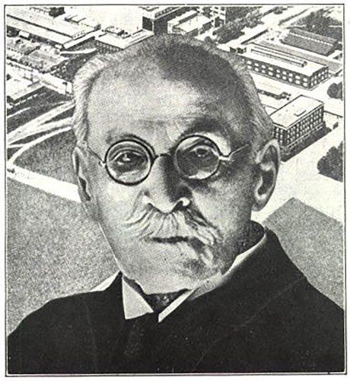  https://westpress.art/go/A4
Frederick Walton
By the late nineteenth century, linoleum flooring had become ubiquitous. It was cheap, durable, easy to clean, and available in various colors and patterns. Working-class homes, schools, shops, hospitals, and factories used linoleum extensively. It was democratizing in its way—a material that brought affordable, cleanable, attractive flooring to ordinary people regardless of wealth.
Linoleum's very ubiquity and association with ordinary domestic and commercial use meant that serious artists dismissed it. It was a utilitarian material, humble, commercial, essentially anti-artistic in their view. The hierarchies that valued fine art oil paintings, watercolors, and rare prints naturally devalued materials associated with mass production and working-class interiors.
The manufacturing process reinforced these associations. Linoleum was an industrial product, made in factories, produced in standardized sheets, sold for practical purposes. It lacked the handcrafted, individual quality that the Arts and Crafts movement and academic aesthetics valued. That it could be purchased inexpensively and used by anyone made it seem unsuitable for serious artistic purposes.

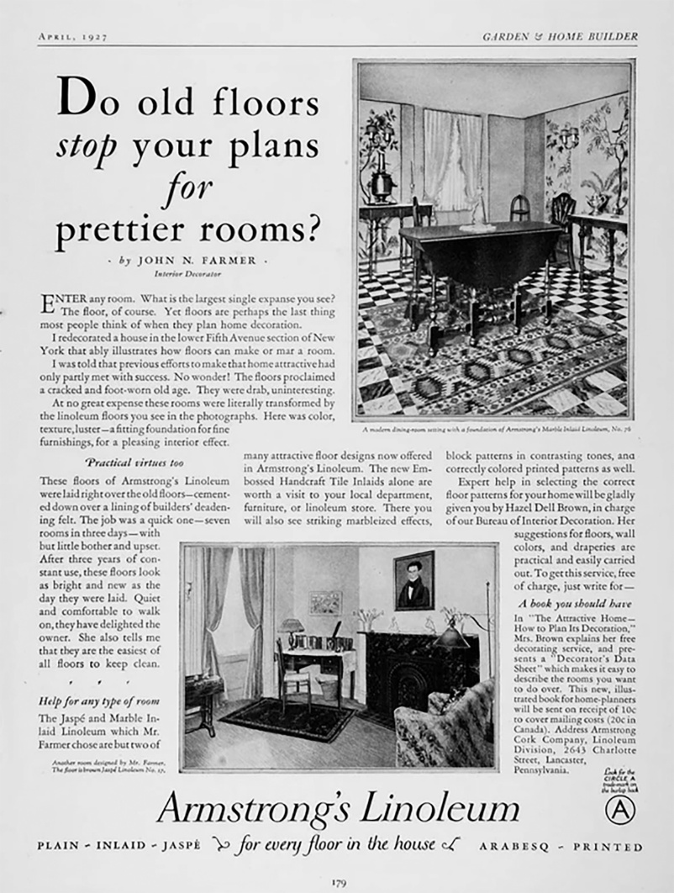

Linoleum's Properties as a Carving Surface
Despite its humble associations, linoleum possessed genuine practical advantages as a surface for relief printing. Relief printing—the process of carving away material to create an image, then using the raised surface to print—was an ancient technique. Woodblock printing, most famously from China, Japan, and Europe, had created acknowledged masterpieces for centuries.
Woodcut, however, had limitations. Wood varies in grain, hardness, and consistency depending on the specific tree and section. Some wood is prone to splitting or cracking. Working with wood requires adapting to these material variations—experienced woodcarvers learn to read and work with the wood's particular character, sometimes embracing happy accidents and unexpected effects that the wood's nature produces.
Linoleum, by contrast, was manufactured to be uniform and consistent. Every sheet of linoleum had the same surface texture, the same cutting properties, the same resistance. This consistency meant greater predictability and control. A carver working in linoleum knew precisely how the tool would behave. There were no surprising grain structures, no hidden knots or structural vulnerabilities, no need to adapt to material idiosyncrasies.

This predictability, which some might have seen as reducing artistic spontaneity, actually offered significant advantages. A design could be executed with precision and confidence. Fine details could be achieved reliably. The carver could focus on aesthetic intention without worrying about material surprises.
Additionally, linoleum was softer and easier to cut than most woods. Carving tools moved through linoleum readily, requiring less physical force. This made the medium more accessible to artists and printmakers without extensive training in woodcarving techniques. A painter or graphic artist could potentially work in linocut without years of apprenticeship in carving craft.
The surface of linoleum could be cut and re-cut without damage that might compromise subsequent printing. A line could be removed if the artist changed their mind—a block could be scraped and reworked more easily than wood. This flexibility encouraged experimentation and revision.
Early Commercial Use of Linoleum Carving
Before Flight discovered linocut's artistic potential, linoleum carving had been used commercially and decoratively. Commercial graphic designers used linocut for producing inexpensive illustrations and designs for newspapers, magazines, and advertising. The ability to produce multiple impressions relatively easily made linocut practical for commercial reproduction.

Decorative artists and craftspeople explored linocut for creating patterns, designs, and decorative effects. Art schools sometimes taught linocut as a craft or commercial graphic skill, not as fine art. It was categorized with commercial design and technical drawing rather than with painting and sculpture.
In this commercial and craft context, linocut had developed a technical sophistication. Practitioners understood how to achieve various effects, how to manage color registration in multi-block printing, how to optimize designs for printability and impact. This technical knowledge would later prove invaluable when Flight began exploring linocut as a fine art medium.
But the very association with commercial use and craft practice made linocut unsuitable, in art world perception, for serious artistic expression. A material used for commercial advertising, newspaper illustrations, and decorative pattern-making could not, it was assumed, serve as a vehicle for fine art. The hierarchy was absolute and apparently obvious: painting and printmaking from copperplate or stone were fine art; linocut was commercial craft.
The Artistic Prejudice Against Printmaking Generally
To understand the skepticism toward linocut specifically, one must understand the broader prejudice against printmaking in academic and elite art circles. Printmaking as a category ranked below painting and sculpture in established hierarchies. Among printmaking mediums, certain techniques were considered more prestigious than others.
Copperplate engraving and etching were respected, partly because their technical difficulty and cost meant they were typically practiced by professionally trained specialists, and partly because the tradition connected to Old Masters and centuries of sophisticated practice. Lithography, developed in the late eighteenth century, achieved some respectability, particularly in France, where artists like Toulouse-Lautrec and other modernists embraced it.
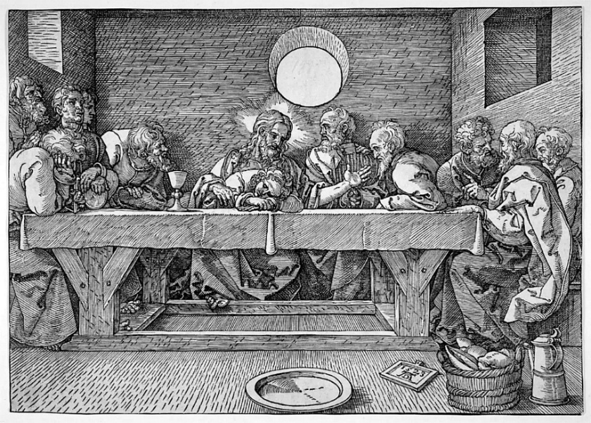 https://westpress.art/go/A5
Woodblock printing occupied an ambiguous position in Western art. In the context of Japanese aesthetics and traditional Japanese art, woodblock was recognized as producing masterpieces. European printmaking also had woodblock traditions, particularly in Northern Europe, where woodcut had been important since the Renaissance. Yet Western academic tradition still ranked woodblock below engraving or etching.
The reasons for these hierarchies were complex. They reflected partly the cost and technical difficulty of different mediums—more difficult mediums seemed to confer more artistic merit. They reflected partly the aesthetic properties of different techniques—engraving could produce subtle tonal effects through intricate hatching that seemed more "refined" than the bolder marks of woodcut. But they also reflected snobbery and historical contingency. Academic tradition simply had established certain mediums as superior to others.
The fundamental prejudice against all printmaking, regardless of specific technique, stemmed from the nature of printing itself. Fine art, in academic understanding, was supposed to produce unique objects—paintings that existed as singular creations, sculptures that were individual works. Printmaking produced multiples—many identical or nearly identical impressions from the same block or plate.
This capacity for reproduction, which in commercial contexts was considered an advantage (you could produce many copies economically), was seen as a disadvantage artistically. If something could be reproduced, so the logic went, it couldn't be truly art. True art was rare, unique, irreplaceable. Printmaking's fundamental nature—its capacity to generate multiple impressions—seemed to disqualify it from fine art status.
This prejudice was so deeply embedded that even artists who worked extensively in printmaking often justified their practice by emphasizing the craft and skill involved, the uniqueness within the multiple impressions (variations in inking, printing, and wear could create different characteristics across an edition), or by treating printmaking as secondary to their "real" work as painters.
Linoleum as Worst-Case Scenario
Within this hierarchy, linoleum occupied the lowest position. It was not just printmaking (already suspect), but commercial printmaking. It was not skilled craft—any moderately competent person could carve into linoleum after brief instruction. It was not expensive or rare. It was mass-produced, humble, democratic.
The material itself communicated lowness. Wood suggested natural material, craft tradition, connection to nature. Stone suggested permanence, classical tradition, monumental art. Copper suggested precious material, technical sophistication, Old Master connections. Linoleum suggested flooring, utility, commerce.

The cheapness and accessibility of linoleum actively worked against its artistic credibility. If materials were expensive and difficult to work, serious artists would undertake the challenge, which justified the medium's status as worthy of serious attention. Linocut was too easy, too accessible, too cheap. Anyone could try it. That very democratization of access that might seem a virtue—art for everyone—was perceived as fatal to artistic status.
Furthermore, linocut's industrial production and uniformity seemed antithetical to artistic authenticity and handcraft values. The Arts and Crafts movement celebrated individual artists working with materials through direct labor, creating objects that bore the mark of individual creativity and manual skill. Linoleum, an industrial product, seemed to violate these values fundamentally. It represented precisely the mass production that the Crafts movement opposed.
The visual associations reinforced these biases. Linoleum was colored in utilitarian shades—browns, greens, blacks. When used for flooring, it was covered with practical patterns. The very sight of a piece of linoleum conjured associations with kitchens, bathrooms, commercial institutions. It lacked the aesthetic resonance of materials with cultural prestige.
Flight's Radical Proposition
It was into this context of absolute prejudice and dismissal that Claude Flight began exploring linoleum in the late 1910s and early 1920s. His proposition was nothing short of revolutionary in its implications: linoleum, the most despised and lowly material in the art world's hierarchy, possessed extraordinary artistic potential.
This wasn't mere contrarianism or deliberate provocation for its own sake—though some element of challenging artistic orthodoxy may have motivated Flight. Rather, Flight had come to understand through practice and reflection that the qualities that made linoleum unprestigious actually made it artistically superior for certain purposes.
Linoleum's uniformity and predictability meant that an artist could execute designs with precision and confidence. The ease of carving meant that artists could focus on aesthetic intention without being distracted by material difficulty. The capability to produce multiple impressions meant that art could be made affordable and accessible to ordinary people.
Most radically, Flight proposed that printmaking itself—the capacity to create multiple impressions—was not an artistic liability but a potential virtue. If art should be democratic, available to people of modest means, then a medium that produced multiple impressions was more aligned with democratic values than unique paintings destined for wealthy collectors.
These ideas were implicit in Flight's practice before they became explicit in his teaching and writing. By the early 1920s, however, Flight was articulating them clearly. He began using linoleum for his own artistic practice. He began developing sophisticated techniques for color linocut. And crucially, he began teaching linocut as fine art, not as commercial craft.
This last point was crucial. Teaching linoleum in art schools traditionally positioned it as a commercial or craft skill. Flight taught it as fine art, with all the seriousness and aesthetic sophistication applied to any medium. Students were encouraged to treat linocut with the same artistic intention, the same concern for composition and design, the same pursuit of excellence as one would bring to any fine art medium.
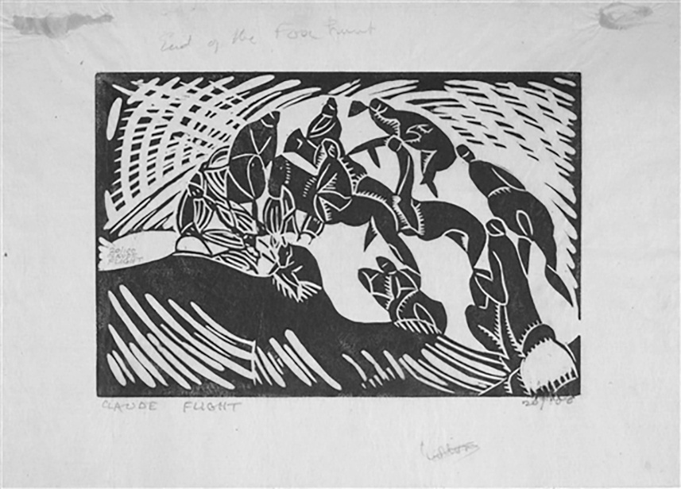 https://westpress.art/go/A6

The end of the fox hunt

By treating linoleum with respect and sophistication, by exploring its technical possibilities thoroughly, by creating images of genuine artistic merit using linocut, Flight began the process of rehabilitating the medium. The transformation from dismissed commercial material to fine art medium wouldn't happen overnight, and Flight himself wouldn't live to see complete acceptance of linocut as legitimate fine art. But the seeds of this transformation were planted in his early practice and developed systematically through his teaching.
What made this transformation possible was Flight's conviction, born from his own artistic experimentation and philosophical reflection, that artistic hierarchies were contingent rather than absolute. Materials and techniques derived their status not from inherent properties but from cultural assumptions and historical habit. These assumptions could be challenged and changed through practice and demonstration.
By creating artistically excellent work in linocut, by developing sophisticated technical approaches, by teaching seriously and demanding excellence from students, Flight demonstrated that linoleum could support artistic ambition and achieve serious artistic results. The transformation of linocut from despised commercial material to respected fine art medium was ultimately an achievement of artistic excellence and persuasive demonstration rather than theoretical argument.

CHAPTER 3: ESTABLISHING THE SCHOOL
The Founding of the Grosvenor School of Modern Art (1926)
The 1920s were a decade of cultural ferment and possibility in London. The trauma of World War I had shattered Victorian certainties and old social orders. The post-war years brought economic disruption and uncertainty, but also intellectual and artistic ferment. Younger artists and intellectuals questioned established institutions and aesthetic orthodoxies. There was appetite for new ideas, new forms, new ways of imagining artistic practice and education.
It was in this cultural moment that Claude Flight made the decision to establish his own art school. The Grosvenor School of Modern Art would open in 1926, initially in modest circumstances but eventually developing into one of the most significant experimental art schools in twentieth-century Britain.
Why Establish a New School?
By the mid-1920s, Flight had refined his vision of artistic practice and education. He had explored extensively with linocut. He had developed color printing techniques. He had begun teaching at conventional art institutions, including the Central School of Arts and Crafts. But he found existing institutions too bound by tradition and hierarchy to fully support the radical pedagogy and artistic experimentation he believed necessary.
[Illustration Placeholder: Photograph of Central School of Arts and Crafts, London]
The Royal Academy Schools, while rigorous, remained wedded to academic tradition. They emphasized classical principles, hierarchy of mediums, and respect for established artistic authority. Innovation was welcomed only within narrow parameters—students were expected to master tradition before, perhaps, departing from it. The fundamental assumption that painting and sculpture were superior to printmaking, that unique objects were more valuable than multiples, that fine art was distinct from craft—these assumptions persisted despite post-war cultural questioning.
Art schools more oriented toward modern practice, like the Slade School of Fine Art, were more experimental. But even progressive institutions operated within institutional constraints. They answered to academic hierarchies. They employed faculty committed to different aesthetic principles. They maintained curricula designed to train students in conventional ways regardless of individual faculty members' desires for innovation.
Flight believed that genuine artistic experimentation required a different institutional setting. He wanted to establish a school organized around principles he had come to believe were essential: that artistic hierarchy should be fundamentally challenged, that linocut and printmaking deserved equal status with traditional fine art mediums, that artistic education should encourage innovation and individual voice rather than conformity to established tradition, that art should be accessible and democratic rather than exclusive to the wealthy and educated.
Establishing his own school would allow Flight to implement these principles completely rather than working within institutional constraints that limited radical experimentation. The decision to found the Grosvenor School was thus not primarily about ego or personal ambition—it reflected Flight's conviction that existing institutions could not support the kind of artistic revolution he believed necessary.
Location and Institutional Structure
The school was located on Grosvenor Road in Chelsea, a neighborhood that had become home to numerous artists' studios and galleries. Chelsea's artistic community, while perhaps not as bohemian as its reputation suggested, provided a cultural environment conducive to artistic innovation. Galleries, studios, and informal artistic community created an atmosphere that supported experimental work.
The location on Grosvenor Road was relatively modest—the school operated in spaces suitable for teaching and studio work but without grand institutional setting or elaborate facilities. This modesty reflected partly financial constraints (the school was established on a relatively limited budget) and partly philosophical commitment to unpretentiousness. The school's equipment was practical and functional rather than luxurious. The teaching spaces were working studios where actual artistic production occurred.
This working-studio atmosphere was deliberate. Flight rejected the model of art school as genteel institution where students learned technique in comfortable but somewhat artificial settings. The Grosvenor School would be a place where real artistic work happened—where students and faculty worked alongside each other, where experimental ideas were tested immediately, where the boundary between teaching and practicing art was blurred.
The institutional structure was relatively informal compared to established art schools. There was no elaborate administration, no rigid hierarchy of faculty ranks, no bureaucratic procedures separating teaching from artistic practice. Instead, the school operated more as an artistic collective or workshop where Flight provided leadership and direction but where various artists and instructors contributed to the community's intellectual and creative life.
This informality had advantages and disadvantages. It allowed flexibility and rapid response to new artistic developments. It meant the school could develop pedagogical approaches that wouldn't have been possible in more rigid institutions. It meant faculty and students worked closely together in genuine creative collaboration.
Yet informality also meant limited institutional protections or security. The school had no endowment, no guaranteed funding, no permanent institutional status. Its existence depended substantially on Flight's continued leadership and on maintaining student enrollment. If circumstances changed—if Flight became unavailable, if artistic fashion shifted, if funding dried up—the school would be vulnerable.
This vulnerability would eventually prove historically significant. The school's existence was relatively brief by institutional standards. Operating from 1926 through the 1930s and into the World War II years, the school's main period of influence and innovation lasted roughly fifteen years. Its closure and dispersal during wartime reflected the precariousness of an institution without deeper institutional support.
But for the fifteen years of its main operation, the Grosvenor School became extraordinarily influential in British art and printmaking practice.
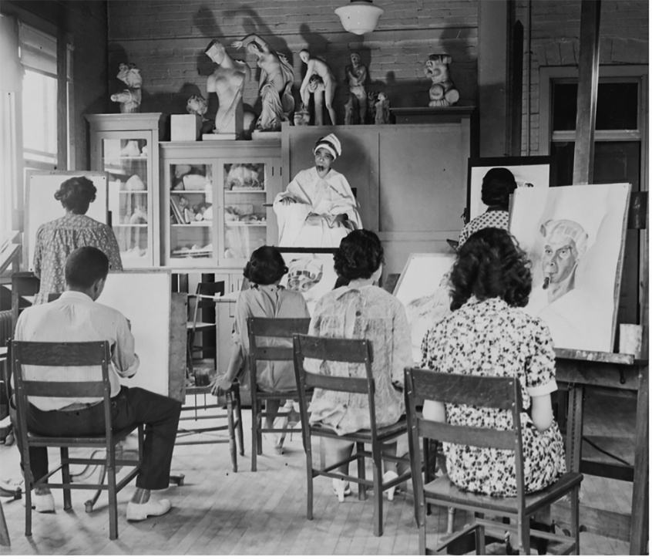
1930s Art Class
Pedagogical Philosophy
The curriculum and teaching approach at the Grosvenor School reflected Flight's fundamental convictions about art education. Most centrally, the school treated printmaking—particularly linocut—as a fine art medium worthy of serious artistic commitment and sophistication, not as commercial craft or secondary practice.
This was radical in its implications. Art schools typically taught printmaking either as a commercial skill (for students planning commercial graphic design careers) or as a supplementary technique (offering some experience with different mediums alongside primary focus on painting and sculpture). The Grosvenor School did something different: it made printmaking, particularly linocut, central to artistic education.
Students could specialize entirely in linocut if they chose. Advanced color linocut techniques received the same serious attention and technical rigor that painting would receive elsewhere. There was no implicit hierarchy suggesting that serious artists would eventually graduate to "real" art—rather, linocut was real art, worthy of complete artistic commitment.
This elevation of printmaking required a fundamentally different pedagogical approach. Rather than teaching linocut as an accessible technique anyone could pick up quickly, the school demanded serious technical study. Students learned the properties of linoleum deeply. They studied how different tools created different marks. They explored color theory in the context of printing. They considered composition and design with the same rigor applied to any fine art medium.
The teaching also emphasized experimentation and innovation. While students received technical instruction in established approaches, they were encouraged to develop individual approaches and experiment with new possibilities. Flight believed that artistic education should liberate creative potential rather than train students to conform to established practice. Innovation and individual voice were encouraged explicitly.
This philosophy meant that the school's curriculum differed significantly from conventional art education. There was less emphasis on copying established models or learning "correct" techniques. There was more emphasis on students developing personal artistic vision and technical approach suited to their individual concerns and sensibilities.
Classes in fundamental art principles—composition, color theory, drawing, design—were taught with awareness that students would apply these principles within experimental rather than conventional contexts. The goal was not to train students to become accomplished practitioners of established techniques but to enable them to develop artistic vision and pursue innovation.
Faculty and Community
The Grosvenor School's strength derived partly from the community of artists and teachers Flight assembled. While Flight provided overall direction and pedagogical vision, the school's intellectual and creative life depended on contributions from multiple people bringing different perspectives and expertise.
Beyond Flight, the school attracted other experienced artists and instructors. These individuals brought different specialties and perspectives. Some were accomplished printmakers with experience in various techniques. Others brought expertise in graphic design or commercial art. Some were younger artists themselves engaged in experimental practice.
This diversity of faculty meant that students encountered multiple artistic sensibilities and approaches. They learned not a single "correct" way of approaching printmaking but various approaches and philosophies. This exposure to diverse practices and thinking encouraged students to develop individual approaches rather than conforming to a single orthodoxy.
Moreover, the faculty themselves appear to have engaged in ongoing intellectual exchange. The school operated partly as an artistic community where faculty members discussed ideas, influenced each other, and developed new approaches collaboratively. The boundary between teaching and artistic practice was permeable—faculty members' own artistic work informed their teaching, and their engagement with students' development influenced their practice.
This collaborative intellectual community was distinctive and appealing. Unlike some art schools where faculty members worked in isolation from each other, the Grosvenor School fostered genuine creative exchange and community. This environment attracted serious artists and intellectuals genuinely interested in advancing artistic practice and education.
Student Recruitment and the Emerging School Community
The school's early years involved building a student community and establishing reputation. Flight actively recruited students, particularly those showing genuine artistic seriousness and openness to experimental approaches. The school was selective—it did not simply accept any student seeking art instruction. Rather, applicants were assessed for genuine artistic interest and capacity for sustained creative engagement.
This selectivity meant the school remained relatively small—never huge numbers of students, but individuals genuinely committed to artistic practice. This modest scale allowed close interaction between students and faculty, genuine artistic mentorship, and development of genuine community.
[
By the early 1930s, the school's reputation had grown substantially. It was recognized as a center of innovative printmaking practice. Students came deliberately to study with Flight, seeking to learn approaches to linocut that were not available elsewhere. The school attracted internationally minded students and achieved growing international recognition.
The emerging community of students would become significant figures in twentieth-century printmaking. Several students from the Grosvenor School would achieve substantial artistic recognition and influence. Their work would carry forward and develop further the principles and techniques Flight had established. Through these students' later work and teaching, the Grosvenor School's influence would extend far beyond the school's actual years of operation.
Distinguishing the Grosvenor School from Establishment Institutions
A crucial aspect of understanding the Grosvenor School's significance is recognizing how fundamentally it differed from establishment art institutions. These differences were not merely superficial or stylistic but reflected an alternative vision of what artistic education should accomplish.
Hierarchy of Mediums: Establishment art schools maintained clear hierarchies in which certain mediums (oil painting, sculpture) were considered fine art while others (printmaking, graphic design, decorative arts) were secondary. The Grosvenor School rejected this hierarchy. Printmaking received the same seriousness and resources as painting. Students could pursue printmaking as a primary artistic direction with full legitimacy.
Individual Innovation vs. Tradition: Establishment institutions emphasized mastery of tradition as foundation for eventual innovation. Students were expected to learn established techniques thoroughly before departing from them. The Grosvenor School encouraged innovation and experimentation from the beginning. While technical foundation was important, students were explicitly encouraged to develop individual approaches and question received wisdom about artistic practice.
Accessibility and Democracy: Establishment art schools, while not explicitly aristocratic, served primarily upper-class and upper-middle-class students who could afford tuition and had leisure for extended study. The Grosvenor School, while not free or necessarily less expensive, emphasized art's democratic potential and accessibility. The school's philosophy held that artistic excellence and individual innovation should not be reserved for elites but should be available to those with genuine commitment and talent regardless of social background.
Integration of Practice and Teaching: In establishment institutions, there was often separation between faculty members' artistic practice and their teaching responsibilities. Art was taught by people whose primary identity was as teachers or academic authority figures, not necessarily as active practitioners. The Grosvenor School integrated practice and teaching. Faculty members were active artists engaged in their own creative work. Teaching occurred in the context of ongoing artistic practice, not as a separate activity.
Experimentation as Central Rather than Peripheral: Establishment institutions valued stability and continuity. Their curricula remained relatively consistent over time. Teaching methods were refined but not fundamentally questioned. The Grosvenor School embraced continuous experimentation with pedagogy and practice. What was taught and how it was taught evolved as Flight and other faculty members' understanding deepened through practice and experience.
These distinctions meant that the Grosvenor School offered something genuinely different to students—not merely an alternative stylistic approach or artistic aesthetic, but an alternative institutional model for how artistic education could operate.
Challenges and Constraints
Despite its influence and innovation, the Grosvenor School faced real challenges and constraints. Most fundamentally, the school operated without secure institutional or financial foundation. Unlike established art schools, the Grosvenor School had no endowment, no government support, no wealthy institutional patron. It depended on student fees and whatever additional funding Flight could generate.
This precarious financial situation meant constant pressure to maintain enrollment and control expenses. The school could not expand facilities significantly or invest substantially in equipment and materials beyond immediate necessities. Staff salaries were modest. Growth was limited by financial constraints.
The school's lack of official recognition or institutional prestige also created challenges. Graduates of established art schools received credentials that were recognized and valued in the conventional art world. Grosvenor School graduates, however innovative, lacked equivalent institutional validation. Their training was recognized by people in artistic communities aware of the school's significance, but to the broader art world, particularly to conservative gatekeepers of artistic authority, Grosvenor School credentials carried less weight than Royal Academy or Slade credentials.
Additionally, the school's emphasis on printmaking and graphic design meant that Grosvenor-trained artists were entering a market that did not fully value these mediums. Even as printmaking gained increasing recognition through the 1930s, painting and sculpture retained superior prestige and market value. Grosvenor graduates pursuing printmaking careers faced a market that undervalued their work compared to painters.
The school also operated in relative isolation from some other significant artistic developments and communities. While the Grosvenor School was clearly modernist and experimental, it was not explicitly aligned with specific artistic movements or schools. It did not identify primarily with Surrealism (though surrealist artists sometimes visited and some student work showed surrealist influence), with Constructivism, or with other specific "isms" defining contemporary modernism.
This autonomy had advantages—it meant the school was not bound by any particular movement's aesthetic orthodoxies. But it also meant the school sometimes seemed peripheral to the major artistic conversations of the period. The Surrealists, for instance, had greater visibility in 1930s cultural criticism and attention than printmakers were receiving, even printmakers engaged in experimental and modernist practice.
Vision Established, Impact Beginning
By the late 1920s, the Grosvenor School of Modern Art had established itself as a significant institutional presence in British art and education. It was recognized as a center of innovative printmaking practice. It had attracted a community of serious students and artists. The school's pedagogical approach and artistic philosophy were recognized as distinctive and influential.
Flight's vision of a school organized around different principles than establishment institutions proved viable and attractive. There was genuine audience for alternative artistic education focused on innovation, experimentation, and printmaking's potential as fine art. The school demonstrated that linocut could support serious artistic practice and ambitious artistic education.
But the school's real period of influence and innovation lay ahead. Through the 1930s, the Grosvenor School would develop more fully its artistic possibilities, attract students who would become significant figures in twentieth-century art, develop technical innovations that would define how linocut could operate, and create works that would eventually achieve recognition as significant modernist achievements.

CHAPTER 4: THE LINOCUT CIRCLE EMERGES
Students, Community, and the Flowering of Innovation (1926-1933)
As the Grosvenor School of Modern Art developed through its late 1920s and early 1930s years, a distinctive community of artists emerged. The students who came to study with Flight, and the work they created, formed what might be termed "the linocut circle"—a community of printmakers united by commitment to linocut as a serious artistic medium and engaged in ongoing creative collaboration and artistic development.
This circle extended beyond the formal boundaries of the school. Some significant artists associated with the linocut circle were not students at the school but rather colleagues working in related artistic contexts, influenced by or collaborating with Flight and school faculty and students. The circle also extended geographically—while centered at the school in London, its influence reached artists in other cities and eventually internationally.
The Students: Sybil Andrews and Early Success
Among the first cohorts of students at the Grosvenor School was Sybil Andrews, a young artist whose talent and commitment would eventually make her one of the most significant figures in twentieth-century printmaking. Andrews' career and influence would ultimately exceed even Flight's in certain respects, though Flight's foundational innovations made Andrews' achievements possible.

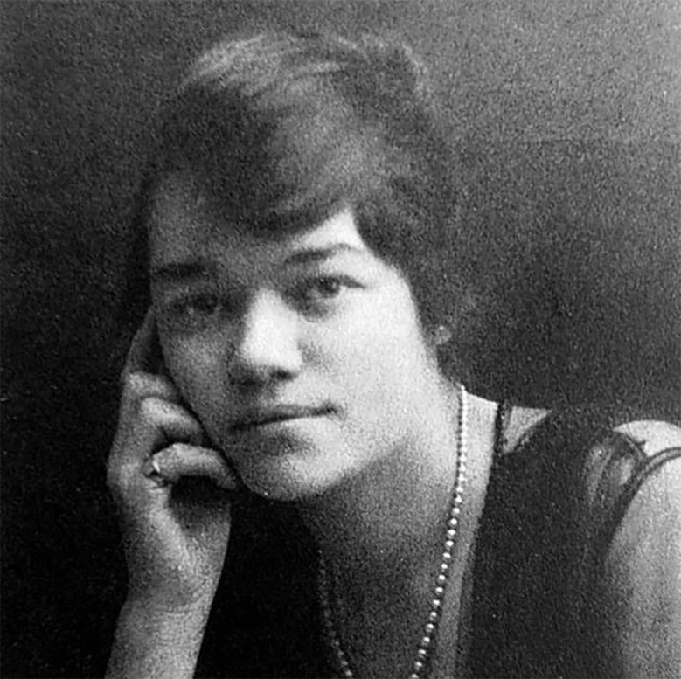  https://westpress.art/go/A7
Sybil Andrews
Sybil Andrews (1898-1983) came to the Grosvenor School with previous artistic training and experience. She had already studied at Clarendon Art School and worked as a commercial artist and graphic designer. This background in commercial design provided a foundation in design thinking and visual communication that proved valuable for understanding linocut's graphic potential.
What Andrews brought to the school was not only technical skill but genuine artistic ambition and distinctive visual sensibility. She engaged seriously with Flight's innovations in color linocut while developing her own distinctive approach and subject matter. Her prints from the early 1930s show mastery of technical processes and sophisticated artistic vision.
Andrews' early prints depict contemporary subjects—urban scenes, workers, industrial landscapes, figures in motion. Her compositions emphasize dynamic movement and energy. She employed bold color relationships and geometric abstraction to convey a sense of contemporary life and modern vitality. The prints show influence of Machine Age aesthetics and modernist visual language, but applied to depiction of recognizable contemporary subjects.

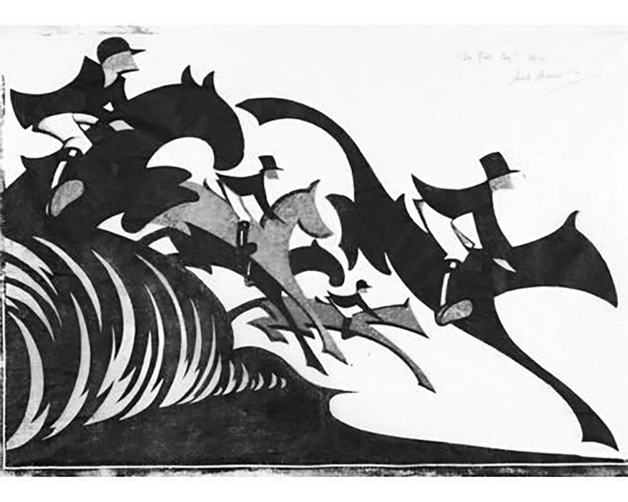 ahttps://westpress.art/go/A8
Sybil Andrews, In Full Cry (1931)
What distinguished Andrews' work even in these early years was a particular sensitivity to line and mark-making. While Flight sometimes emphasized bold color fields and strong contrasts, Andrews' compositions frequently built visual complexity through accumulated linear marks and subtle color relationships. Her approach to composition created a sense of energy and movement through accumulation of smaller marks rather than through simple bold forms.

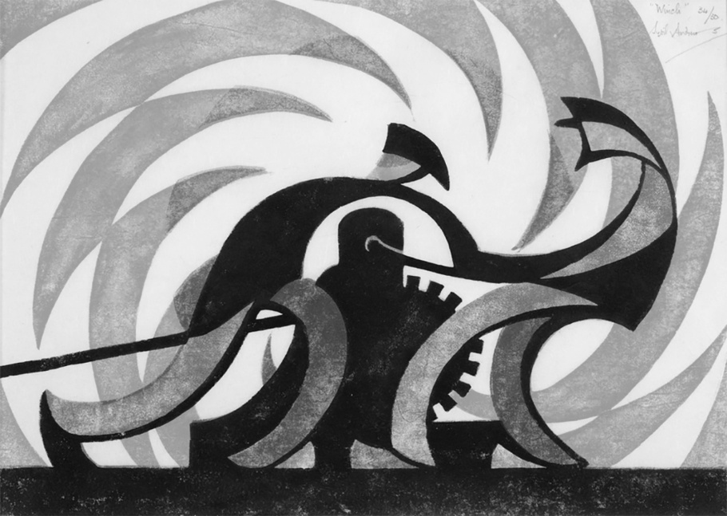 https://westpress.art/go/A9
Sybil Andrews, The Winch (1930)
The Emerging Community: Cyril Hamersly, Lill Tschudi, Margaret Macdonald
Alongside Andrews, other students emerged whose work would define the Grosvenor School's distinctive aesthetic achievement. Each brought individual perspective and artistic concern while participating in a shared community organized around linocut innovation.
Cyril Hamersly (1901-1988) developed a highly distinctive approach to linocut emphasizing geometric abstraction and formal investigation. His prints moved away from representational imagery toward abstraction that explored pure relationships of form, line, and color. Hamersly's compositions frequently featured strong geometric forms—circles, rectangles, triangles—arranged in dynamic relationships. His work showed influence of Constructivism and geometric abstraction developing in European modernism, but applied specifically to the linocut medium.

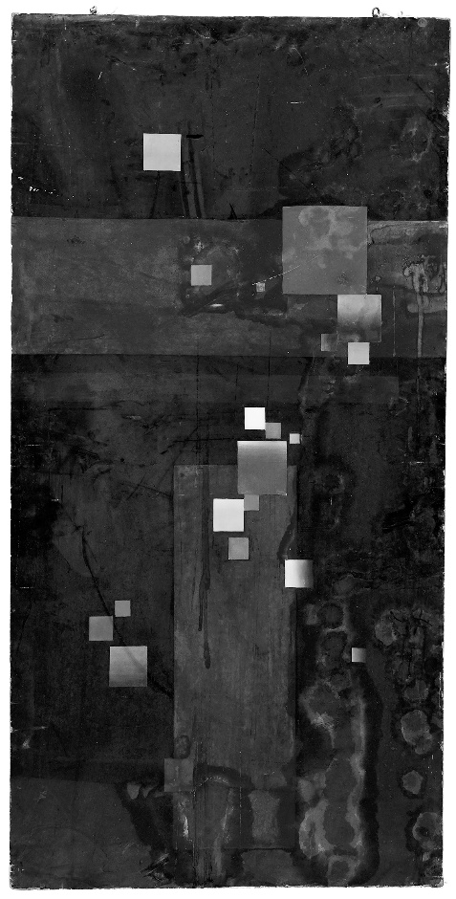
https://westpress.art/go/A10
Cyril Hamersly Abstract on Black Ground, oil on board unsigned
Hamersly's approach represented one direction linocut could develop—toward formal abstraction relatively independent of representational imagery. His work demonstrated that linocut could support the same kind of formal and conceptual investigations that abstract painting was pursuing. This was significant precisely because it challenged assumptions that printmaking was inherently tied to representational imagery, that prints necessarily depicted something recognizable.
Lill Tschudi (1911-2000) brought particular interest in color and subtle gradations of tone. Her prints employed sophisticated color relationships and careful tonal modulation. Rather than using bold primary colors, Tschudi frequently worked with restrained palettes—limited colors deployed with great precision to create visual effects through relationship rather than through contrast.
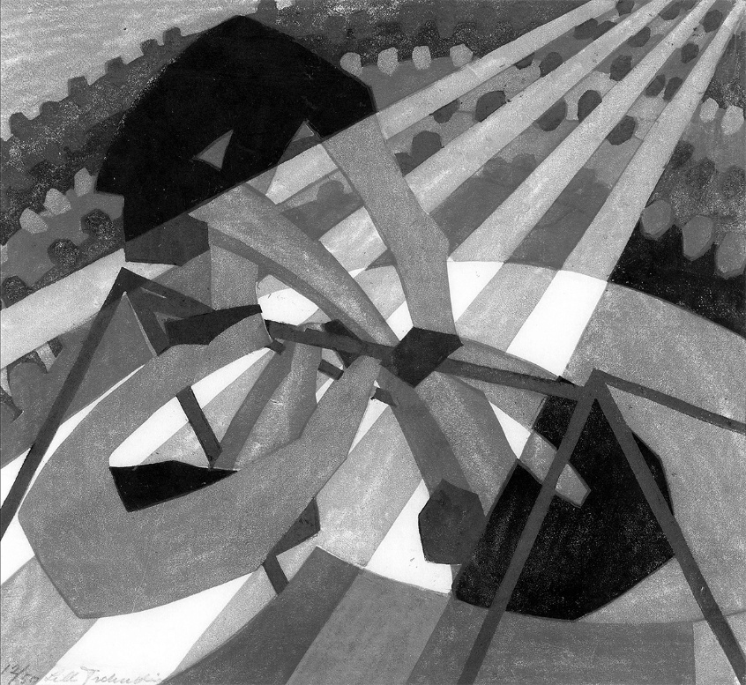  https://westpress.art/go/A11
Lill Tschudi, In the Circus (1932)
Tschudi's technical innovations in color printing influenced the school's development. She experimented extensively with registration systems and approaches to managing color overlap and transparency. Her prints demonstrated that linocut could achieve the kind of subtle color refinement that lithography was known for—a significant technical achievement that expanded understanding of linocut's possibilities.

Cross-Influence and Artistic Development
A crucial aspect of understanding the linocut circle is recognizing how artists influenced each other and developed ideas through ongoing interaction and dialogue. The school operated partly as an artistic community where ideas circulated and developed collaboratively.
Students saw each other's work constantly. The school's working-studio atmosphere meant that artistic development was not private or isolated but shared and visible. Students could observe each other's experiments, discuss approaches, learn from each other's successes and failures. This circulation of ideas and aesthetic engagement accelerated artistic development and fostered mutual influence.
The boundary between students and faculty was permeable in artistically productive ways. While Flight provided direction and guidance, students' work and ideas influenced faculty thinking. New possibilities emerged through students' experiments that faculty members might not have pursued alone. The school operated as a genuine artistic community where learning and influence flowed in multiple directions rather than simply from faculty to students.
Particular relationships and friendships developed among students, relationships that fostered artistic collaboration and exchange. Some students worked closely together, discussing ideas, influencing each other's developing approaches. These peer relationships were as artistically significant as formal instruction from faculty.
This collaborative creative community distinguishes the Grosvenor School from typical art schools where students primarily learn from faculty instruction and may develop only superficial relationships with each other. The Grosvenor School actively fostered genuine artistic community and peer learning, recognizing that artistic development is fostered as much through peer exchange and shared creative exploration as through formal instruction.
Exhibitions and Emerging Recognition
The work of Flight and students was exhibited regularly through the late 1920s and early 1930s. These exhibitions were crucial for establishing the linocut circle's reputation and for gaining broader recognition of linocut as a fine art medium.
Early exhibitions at London galleries introduced the Grosvenor School's work to London's artistic public. Some exhibitions were organized by the school itself or by associated galleries. Others involved participation in group exhibitions organized by artistic societies and alternative venues.
International exhibitions extended the linocut circle's influence beyond Britain. Work by Flight and school students was exhibited internationally, earning recognition from artistic communities in Europe and beyond. This international exposure was significant because it demonstrated that the British innovations in linocut were not merely local phenomena but contributions to broader modernist artistic practice.
The critical response to these exhibitions was mixed. Enthusiasts recognized the technical sophistication and artistic innovation. Progressive critics and artists engaged seriously with the work, recognizing linocut's potential as demonstrated by the school's practitioners. But conservative critics and establishment figures often remained skeptical or dismissive. The prejudice against printmaking generally and linoleum specifically had not disappeared—it had only begun to erode.
Yet with each exhibition, with each demonstrated achievement, the prejudice weakened slightly. Collectors began acquiring Grosvenor School prints. Museums began acquiring work for their collections. The artistic establishment, while not yet fully accepting linocut as equal to painting and sculpture, began acknowledging the seriousness and quality of the work being produced.
The School's Influence on British Art
By the early 1930s, the Grosvenor School of Modern Art had achieved significant influence on British artistic practice and culture. The innovations in color linocut and the artistic achievements of Flight and students attracted attention and respect. The school became recognized as a center of modernist innovation and experimental artistic education.
This influence extended beyond those directly associated with the school. Other artists, learning of the school's work, began exploring linocut possibilities independently. The demonstration that serious artistic achievements could be created through linocut inspired practitioners who had not studied at the school to reconsider the medium's potential.
The school's influence also affected broader artistic education. While established art schools maintained their traditional hierarchies and curricula, the success and visibility of Grosvenor School innovations created pressure for reconsideration. Some other art schools began giving increased attention to printmaking and graphic design. The rigid hierarchy that had previously been simply accepted began to be questioned and challenged.
The school's pedagogical approach—emphasizing experimentation, individual voice, and innovation—influenced thinking about art education more broadly. Progressive educators interested in alternative approaches to artistic training looked to the Grosvenor School as a model of how things might be done differently.
International Recognition and Connections
The linocut circle's influence extended internationally. The work of Flight, Andrews, and others became known to artists and artistic communities across Europe and beyond. International connections developed through exhibitions, artistic publications, and direct relationships between artists working in different countries.
German printmaking communities were particularly engaged with British linocut innovations. Germany had a strong tradition of printmaking and graphic design, and German artists recognized the significance of what was being achieved in Britain. There was artistic exchange and mutual influence between British and German printmakers, though this exchange was disrupted by the rise of the Nazi regime and political polarization of the 1930s.
Scandinavian countries, particularly Sweden and Denmark, developed their own communities of linocut practitioners influenced by British developments. Japanese artists, working in traditional woodblock printmaking traditions, recognized the sophisticated approaches being developed in British linocut and engaged with this work, sometimes leading to direct artistic exchange.
This international recognition validated the British innovations. It demonstrated that the work being produced at the Grosvenor School was not merely a local phenomenon but a contribution to international artistic practice. It established linocut as a medium of international significance, not merely a British novelty.
The Question of Identity and Community
An interesting aspect of the linocut circle was the question of whether it constituted an artistic "movement" in a formal sense or whether it was better understood as a community of practitioners united by shared commitment to a medium and certain artistic principles.
The linocut circle did not have the kind of formal manifesto or explicit theoretical framework that characterized some modernist movements. There was no publication equivalent to Vorticism's BLAST declaring principles and attacking enemies. There was no unified aesthetic doctrine that all members were required to follow.
Yet there was genuine community identity. Practitioners associated with the Grosvenor School recognized themselves as part of a shared enterprise. They identified with Flight's vision of linocut as a serious artistic medium. They engaged in dialogue about artistic directions and technical possibilities. They supported each other's work and exhibited together.
This looser form of community organization had advantages and disadvantages. It allowed individual artists greater freedom to pursue diverse aesthetic directions than would have been possible within a more rigid movement structure. But it also meant that the movement lacked the kind of clear identity and unified impact that more organized movements achieved.
Understanding the linocut circle as a community of practice rather than a formal movement seems most accurate. What unified the practitioners was not shared aesthetic doctrine but shared commitment to a medium, shared belief in its potential, and shared participation in a community of artistic practice and exchange centered at the Grosvenor School.

CHAPTER 5: TECHNICAL INNOVATION AND MASTERY
Developing the Possibilities of Color Linocut
The revolutionary potential of linocut as a fine art medium could only be realized through systematic technical innovation. Claude Flight, along with students and colleagues, engaged in ongoing technical experimentation and development. Through this work, they discovered and developed techniques that allowed linocut to achieve visual sophistication and range previously thought impossible for the medium.
This technical development was not separate from artistic practice—rather, technical innovation and artistic expression developed in dialogue with each other. New technical possibilities enabled new artistic visions. Artistic ambitions drove technical innovation. The continuous interplay between technical exploration and artistic intention characterized the school's practice.
The Basic Technique of Linocut
Before examining the innovations Flight developed, it is useful to understand the basic linocut process and its fundamental characteristics.
Linocut printing is a relief printing process. An image is carved into a linoleum block by removing material from the surface. The raised portions of the block that remain uncarved are inked and printed. This basic process is ancient and simple in principle, but it allows for sophisticated refinement and variation.
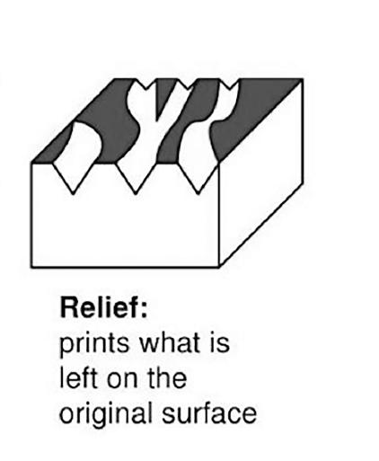
A single-block linocut produces a black and white image (or images in one ink color). The carver uses tools of varying sizes and shapes to remove linoleum, creating marks that range from fine lines created by small sharp tools to large areas cleared away with broad tools. The pattern of removed and remaining linoleum creates the image. When ink is applied to the block and the block is pressed onto paper, the raised inked portions transfer to paper, creating the print.
The image appears reversed compared to the carved block—what appears on the left of the carved block appears on the right in the print. This reversal is characteristic of relief printing and requires carvers to think in reverse, which becomes second nature with practice.
The process allows for relatively rapid execution compared to some printmaking techniques. Carving tools move through linoleum readily. Images can be executed in relatively short time compared to, say, etching or lithography. This speed makes linocut a practical medium for producing multiple impressions efficiently.
The mark-making qualities of linocut create distinctive visual effects. Carved lines appear as white lines in the print (where the linoleum has been removed, ink is not applied). The direction of carving marks is often visible in the print, giving the work a characteristic linear quality. Bold marks are possible, as are fine details if carved carefully with appropriate tools.
Single-block linocut creates images fundamentally in black and white (or one color and white). This limitation compared to painting's ability to render any color was long assumed to be an inherent limitation of the medium.
The Revolution: Color Linocut
The crucial innovation Flight developed was a sophisticated approach to multi-block color linocut. This technique allowed artists to create linocut prints with multiple colors, dramatically expanding the medium's expressive possibilities.
Multi-block color printing was not new—Japanese woodblock printing had developed sophisticated multi-block color techniques centuries earlier. European lithography employed multi-block or multi-stone color printing. But the adaptation of multi-block color techniques to linocut, and the particular approaches Flight developed, was genuinely innovative.
The basic principle of multi-block color linocut is conceptually simple. Different blocks are prepared for different colors. Each block is inked with a single color. The paper is printed successively against each block, with precise registration (alignment) ensuring that colors overlay precisely. The result is a print with multiple colors created through successive printing passes.
But implementing this process with precision and achieving satisfactory results required developing specific technical approaches and solutions.
Registration Systems: The fundamental technical challenge was achieving reliable registration—ensuring that successive color passes aligned precisely. Any variation in positioning would create misalignment, resulting in colors appearing in wrong places and disrupting the image.
Various registration systems were developed. Some used small marks printed at block edges that could be aligned by hand. More sophisticated systems used mechanical registration aids—guides that could position paper precisely for each color pass. Experimentation led to increasingly refined registration methods that allowed precise alignment with minimal waste and frustration.

Flight developed registration approaches suited specifically to linocut's characteristics. Understanding that paper would move slightly depending on humidity and handling, he created systems that compensated for these variations while maintaining workable simplicity. The goal was achieving precision without requiring mechanical equipment so specialized that printing became impractical.
Managing Color Overlay: When colors overlap (one color printed over another), the visual effect depends on ink transparency and specific colors employed. Dense opaque inks create color that completely covers what is beneath. Transparent inks allow color underneath to show through. Different combinations create different effects.
Flight experimented extensively with ink formulations and overlaying techniques. He discovered that the order of printing colors affected results—printing light colors first and dark colors last, or vice versa, produced different effects. He explored how different inks would interact when layered.
This experimentation generated practical knowledge about how to achieve desired visual effects through color overlay. Some combinations produced bright, vibrant results through color mixing. Others created subtle effects through transparent color layering. The visual range achievable through color linocut proved far richer than single-block work.
Block Preparation and Carving: Creating separate blocks for different colors while ensuring they worked together harmoniously required careful planning and execution. The same image had to be carved into multiple blocks in ways that the carved elements of each block would register and overlay properly.
One approach involved dividing the image into distinct color zones—one block carved for one color, another for another color. This approach worked well for images with distinct color areas. But achieving more subtle color transitions or allowing colors to overlap created carving challenges.
Another approach, sometimes called "block by block" or "separate block" method, involved each block carrying only the portions of the image that would print in that block's designated color. The blocks would be viewed as a team, with each block contributing its color to the final image. This approach required visualizing the image in decomposed form, imagining how different color separations would overlay to recreate the complete image.
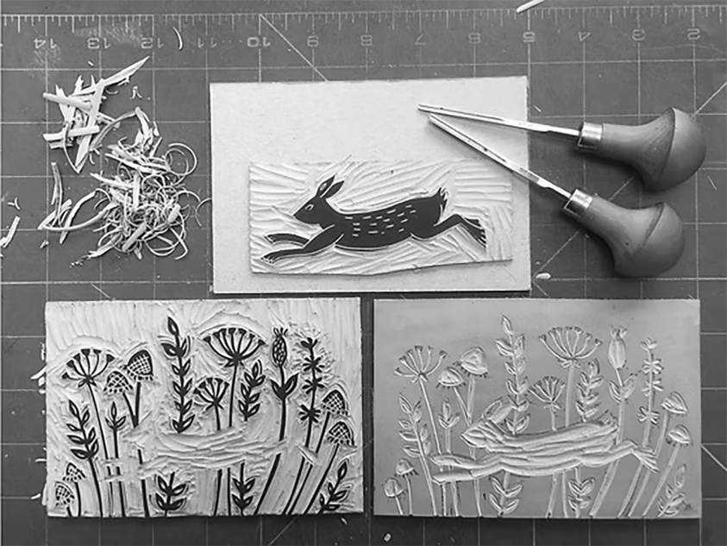  https://westpress.art/go/A12
Multiple block technique from Michelle Hughes
Developing skill in managing these technical requirements was essential for achieving successful color prints. The school's teaching involved systematic instruction in how to approach these problems and practice in solving them through direct experience.
Paper and Printing: The choice of paper affected how colors would print and how the final image would appear. Different papers had different absorbencies, textures, and weights. Some papers took ink evenly; others created more textured effects. The paper's color affected how printed colors appeared.
The printing process itself—how much pressure was applied, how ink was transferred to the block, how the block was positioned against the paper—affected results. Consistent printing technique ensured consistent results across the edition.
Tool Innovation and Mark-Making
Beyond multi-block color printing, Flight innovated in tools and approaches to carving. Different tools created different marks and effects. Experimentation with tools expanded the range of possible marks and visual effects.
Traditional linocut relied on relatively simple tools—sharp blades for cutting lines, scoops for removing larger areas, burins borrowed from engraving traditions. But experimentation revealed that other implements could be used effectively. Some artists worked with dental tools, surgical implements, and improvised tools suited to particular effects they desired.
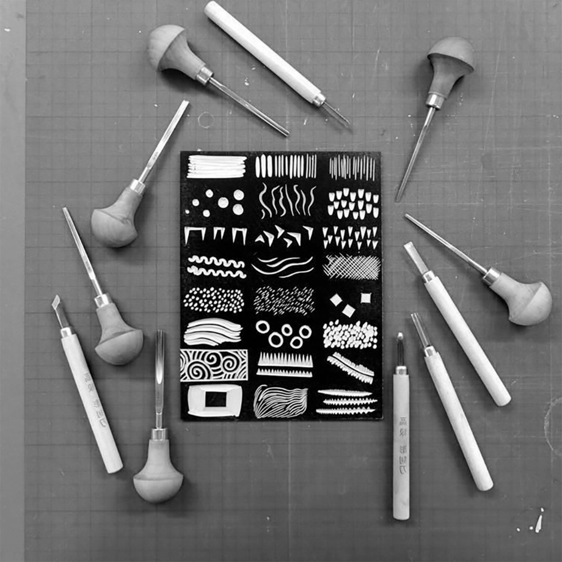
Different marks had different visual characteristics. Fine marks created with small sharp tools created delicate linear effects. Broader strokes with larger scoops created bold statements. Patterns created with repeated marks built visual texture and complexity. Understanding the range of possible marks and how they contributed to visual effects was crucial for developing sophisticated work.
The visible mark-making characteristic of linocut was gradually understood not as a limitation to be overcome but as a distinctive quality to be embraced. The directional quality of carving marks, the visible evidence of tool movement, the characteristic linear quality—these became recognized as aesthetic properties contributing to linocut's visual distinctiveness.
Achieving Tonal Variation and Gradation
One challenge for early linocut was achieving subtle tonal variation and gradation. Woodcut and engraving traditions achieved tonal effects through techniques like cross-hatching (overlaid lines creating darker or lighter effects) and dotting. These approaches could be adapted to linocut but were time-consuming and required careful execution.
Flight explored various approaches to achieving tonal effects. Fine parallel lines created intermediate tones between white (uncarved) and black (inked). Dots and dashes created textural effects that could modulate tone. Different line densities could suggest different tonal values.
The color possibilities of multi-block printing also opened new possibilities for tonal suggestion. Subtle color modulation could create visual effects approximating gradation or tonal variation. A light color in one area, overlaid with partial coverage of a darker color, created intermediate tones. By carefully planning which color blocks would print where, artists could create complex tonal effects through color relationship rather than through hatching.
This discovery was significant because it meant linocut could achieve the kind of subtle tonal sophistication that had been considered the province of engraving or other traditional printmaking mediums. The limitation to simple black and white imagery became less severe once color linocut demonstrated its capacity for tonal subtlety.
Chiaroscuro Effects and Atmospheric Perspective
The term "chiaroscuro," referring to striking contrasts of light and dark and their use to create dramatic effects, came from painting tradition. But printmakers adapted chiaroscuro principles to their mediums.
In linocut, chiaroscuro effects could be achieved through several means. Bold contrasts between heavily inked areas and white paper created dramatic effects. The use of black and dark colors in particular areas combined with white or light colors elsewhere suggested light source and spatial recession. Tonal gradations achieved through hatching or color layering modulated these dramatic contrasts.
Flight developed approaches to achieving atmospheric perspective—the visual effect where distant elements appear lighter and less distinct while foreground elements appear darker and more detailed. Traditional painting achieved this through color and tonal adjustment. In linocut, similar effects could be suggested through controlling mark density, through color choice, and through careful composition.
Several prints by Flight demonstrate sophisticated use of chiaroscuro and atmospheric perspective. These effects, achieved through mastery of linocut technique and thoughtful compositional planning, proved that the medium could achieve subtle visual effects comparable to traditional fine art mediums.
The Technical Mastery Demonstrated in Specific Works
Examining particular works reveals the technical sophistication Flight achieved. These works demonstrate not merely technical competence but genuine artistic mastery expressed through technical command.
Flight's color prints from the early 1930s frequently employ carefully orchestrated color relationships. One characteristic approach involves using a relatively limited palette—perhaps three or four colors—deployed with great precision. The colors interact through both direct juxtaposition (where they meet) and through careful overlay (where one color prints over another). The result is visual complexity achieved through sophisticated control rather than through accumulation of many colors.
The compositions frequently emphasize geometric clarity and dynamic movement. Strong diagonal lines create a sense of energy and forward motion. Forms are simplified and abstracted without losing connection to recognizable subject matter. The overall effect combines modernist abstraction with depiction of contemporary subjects—urban scenes, workers, industrial landscapes, vehicles in motion.
Teaching Technical Mastery
Flight's innovations existed not only in his own practice but in how he taught technical approaches to students. The school's curriculum systematically instructed students in color linocut techniques while encouraging experimentation and individual approach.
Students began with single-block work, learning basic carving and printing techniques. They learned how different tools created different marks. They practiced controlling carving pressure and speed. They learned to ink blocks, position paper, and print with consistency.
Once fundamental skills were mastered, instruction advanced to color linocut. Students learned registration systems and how to plan multi-block compositions. They learned ink formulation and color theory. They experimented with different approaches to color overlay and studied results of various combinations.
Crucially, the teaching was not merely technical instruction divorced from artistic purpose. Students learned techniques in the context of artistic intention. Understanding how color could be managed was taught with reference to how these technical capabilities could serve artistic expression. The goal was not simply to teach technique but to enable students to use technique as a vehicle for artistic vision.
The school's approach to teaching also emphasized learning through experimentation and failure. Students tried different approaches, examined results, and refined technique based on experience. Technical knowledge was developed through practice and discovery as much as through explicit instruction.
This pedagogical approach—combining systematic instruction with guided experimentation—proved very effective. Students developed technical competence relatively quickly while maintaining capacity for continued innovation and individual development. The school's students generally achieved a high technical standard and maintained capacity for artistic independence rather than becoming merely technical copyists of instructors' approaches.
Experimentation and Technical Boundaries
While the school established sophisticated technical approaches that became standard practice, there was also ongoing experimentation with alternative techniques and approaches. Not every experiment succeeded, but the willingness to experiment expanded understanding of linocut's possibilities.
Some experiments involved unconventional tools or carving approaches. Some involved printing techniques different from standard practice. Some involved combining linocut with other mediums or approaches.
These experiments, whether successful or unsuccessful, contributed to technical understanding and kept practice vital and evolving. The school's culture valued innovation and experimentation even when particular experiments did not produce satisfactory results.
The Technical Foundation for Artistic Achievement
The technical innovations and mastery achieved by Flight and the school's practitioners provided a foundation for artistic achievement of lasting significance. Mastery of technique was never an end in itself but was always understood as enabling artistic expression and vision.
Yet without developing technical solutions to linocut's inherent challenges—without solving the color registration problem, without discovering how to achieve subtle tonal effects, without innovating approaches to making the medium capable of sophisticated artistic results—the artistic achievements would have been impossible.
The relationship between technical innovation and artistic vision was symbiotic. Artistic ambitions drove technical innovation—artists wanted to create work with particular characteristics and developed technique to achieve these goals. Technical discoveries opened new artistic possibilities—once certain technical capabilities were established, artists imagined new ways to use them and developed new artistic directions.
This dynamic relationship between technique and vision, between problem-solving and creative imagination, characterized the Grosvenor School's work. Neither technique nor artistic vision could be isolated or prioritized above the other. They developed together through ongoing practice and experimentation.
Comparative Technical Advantages
Understanding linocut's technical characteristics relative to other printmaking mediums helps clarify why the innovations achieved at the Grosvenor School were significant contributions to modernist printmaking practice generally.
Compared to woodcut, linocut offered greater predictability and uniform carving properties. Wood's variable grain and potential for unexpected splitting made woodcut sometimes unpredictable. Linoleum's uniform composition meant that carvers could rely on consistent properties across the block. This consistency allowed more precise technical execution.
Compared to engraving and etching, linocut allowed for bolder marks and faster execution. Engraving and etching required lengthy training and specialized skills. Linocut was more accessible while still capable of sophisticated technical refinement. The bold mark-making characteristic of linocut created distinctive visual effects different from the delicate linear marks of engraving.
Compared to lithography, linocut was simpler to execute technically and required less specialized equipment. Lithography's capabilities for subtle tonal effects were remarkable, but the process involved chemical procedures and stone preparation that made it less accessible than linocut. Linocut could achieve many similar effects through multi-block color printing while remaining more practically accessible.
These comparative advantages meant that linocut, once its potential was recognized and techniques were developed, offered distinctive possibilities to artists. It was not simply an inferior substitute for other mediums but a genuinely different medium with its own particular possibilities and characteristics.
Technical Standards and Quality Control
The school's success in establishing linocut as a fine art medium depended not just on developing technical innovations but on maintaining high standards of technical execution. Work that was carelessly printed or technically incompetent would not have advanced linocut's status.
Flight maintained rigorous standards for work produced through the school. He examined prints carefully. He insisted on proper registration, consistent inking, and clean printing. He was willing to discard prints that did not meet standards. The goal was not to produce the maximum number of prints but to produce prints of genuine quality.
This commitment to technical excellence communicated clearly that linocut was a serious medium deserving technical rigor and careful execution. The high standards maintained by the school distinguished the work from commercial printing or casual experimentation. The work demonstrated that printmaking could embody the same commitment to quality and technical mastery as traditional fine art mediums.
The Legacy of Technical Innovation
The technical approaches developed by Flight and the Grosvenor School became standard practice for linocut printing subsequently. Artists working in linocut after the school's main period benefited from these developments, often using registration systems and color management approaches that had been established at the school.
Contemporary linocut practice continues to employ fundamental approaches developed during this period. While tools and equipment have evolved and some innovations have occurred since the 1930s, the basic multi-block color printing process remains similar to what Flight developed.
This technical legacy is remarkable. The innovations have proven so effective and appropriate to the medium that they have persisted essentially unchanged for nearly a century. Few technical innovations maintain such lasting influence.
Yet the technical innovations are not historically significant merely because they persist. They are significant because they enabled artistic achievements and provided a foundation for transforming linocut from a dismissed commercial medium to a respected fine art practice. The technical work was always in service of artistic vision and cultural transformation.

CHAPTER 6: CLAUDE FLIGHT'S ARTISTIC VISION
Themes, Aesthetics, and the Evolution of Practice
To understand Claude Flight's significance as an artist, it is insufficient to recognize his pedagogical innovations or his role in establishing the Grosvenor School. Flight was, fundamentally, an artist with a distinctive vision and continuing artistic practice that evolved and deepened across his career. His teaching and institutional work were always rooted in and informed by his own artistic investigations and creative commitment.
Flight's artistic vision cannot be reduced to a single statement or simple characterization. It evolved across time, responded to changing circumstances and artistic developments, and integrated multiple influences and concerns. Yet certain consistent themes and aesthetic principles characterized his work throughout his productive years.
The Discovery of Movement and Energy
Central to Flight's artistic vision was a fascination with movement, energy, and dynamism. This concern emerged early in his practice and remained persistent throughout his career. His prints frequently depict subjects in motion—figures moving through space, vehicles traveling, workers engaged in dynamic activity. The compositions emphasize energy and forward momentum through visual means.
This focus on movement reflected both personal sensibility and broader artistic concerns of the modernist period. The machine age, the acceleration of modern life, the energized chaos of contemporary urban experience—these preoccupied artists across Europe in the 1920s and 1930s. Futurist artists had made movement and speed central to their aesthetic philosophy. Constructivist artists in the Soviet Union emphasized dynamism and forward motion as visual expression of revolutionary energy.
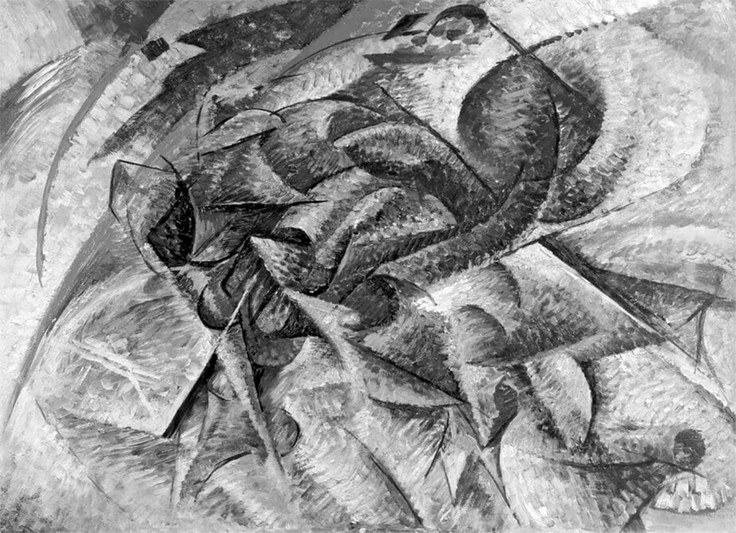
https://westpress.art/go/A13
Flight engaged with these international modernist concerns but through his own distinctive vision. Rather than celebrating speed and machines abstractly as the Futurists did, Flight frequently depicted recognizable contemporary subjects—urban scenes, ordinary workers, everyday activities. His paintings and prints showed modern life in motion, rendered through modernist visual language.
This approach involved simultaneous depiction of recognizable reality and geometric abstraction. A worker carrying materials, a horse-drawn cart, a figure hurrying through city streets—these identifiable subjects were rendered through simplified forms, bold outlines, and dynamic compositional arrangements that suggested movement and energy without literal depiction of motion blur or other mechanical devices.
The result is art that is simultaneously representational and abstract, contemporary in subject matter but modernist in formal language. Viewers can identify what is depicted—a worker or vehicle—while simultaneously experiencing the image as a composition of dynamic geometric forms and energetic lines.
Jazz Age Influences
The 1920s were an era of jazz, of accelerated social change, of new music and dance forms emerging from America and quickly adopted internationally. Jazz represented modernity and spontaneity to younger Europeans. The rhythmic qualities of jazz, its syncopated patterns and unexpected accents, influenced artistic thinking beyond music.
Flight's compositions frequently show jazz-like qualities—syncopated rhythm, unexpected accents, a sense of improvisation within structured form. His prints build visual rhythm through repetition and variation of linear elements, through color that accents particular compositional areas, through compositional arrangements that create a sense of movement and temporal flow.
This jazz-influenced aesthetic represents a different modernist sensibility than either Cubism's static formal investigation or Futurism's celebration of violent speed. It involves movement and energy, but expressed through rhythm and syncopation rather than through depiction of rapid motion or mechanical power.
Several of Flight's most successful prints from the early 1930s embody this quality particularly well. The compositions move the viewer's eye through the image along rhythmic paths. Colors pulse and accent. Forms repeat with variations that suggest musical rather than purely visual organization.
This jazz-age influence connects Flight to broader contemporary cultural developments. Many artists of his generation responded to jazz, cinema, and other new cultural forms. Flight's integration of jazz-influenced aesthetic into visual art represents one of many such translations of modern cultural forms into visual language.
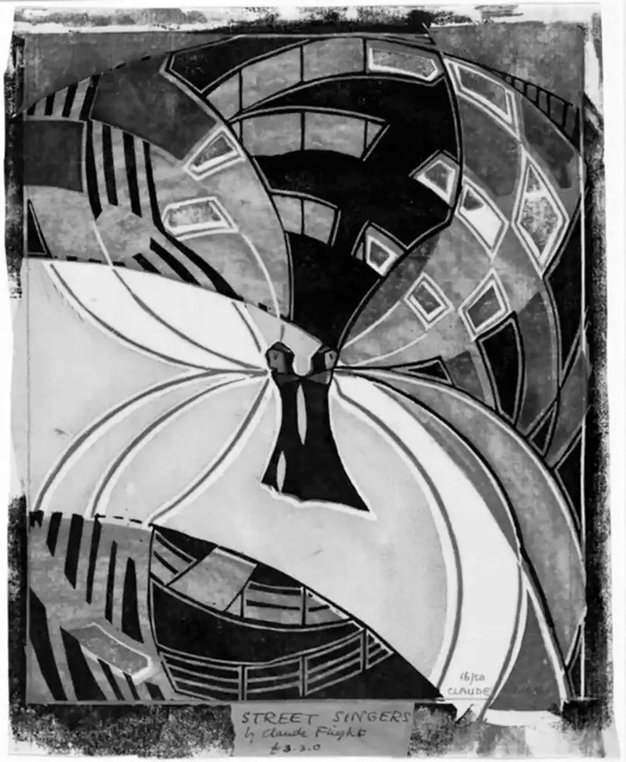
https://westpress.art/go/A14
Claude Flight: Street Singers

Urban and Industrial Subjects
Flight's preference for urban and industrial subject matter reflected his artistic values and his understanding of what subjects should engage modern artists. He believed art should engage with contemporary life, should depict the world artists actually inhabited rather than retreating into historical or mythological subjects.
Urban landscapes—city streets, busy commercial districts, harbors with shipping activity—appear frequently in his work. Industrial scenes—factories, construction sites, workers engaged in labor—are common subjects. These subjects were not unusual for modern artists—many modernists depicted urban and industrial themes. But Flight's particular approach to these subjects was distinctive.
Rather than depicting the industrial world with dystopian critique or as a site of social alienation (concerns that interested some artists), Flight often depicted urban and industrial activity with genuine interest and sometimes enthusiasm. The energy and dynamism of industrial work fascinated him. The geometric forms created by industrial structures and activity appealed to his compositional sensibilities.
This positive or at least neutral relationship to industrial modernity distinguished Flight from some socially conscious artists. He was not interested in industrial imagery primarily as a means of social criticism, though he was alert to social dimensions of modern life. Rather, he was interested in industrial and urban subjects as contemporary reality worthy of artistic attention and as providing rich visual material for artistic investigation.
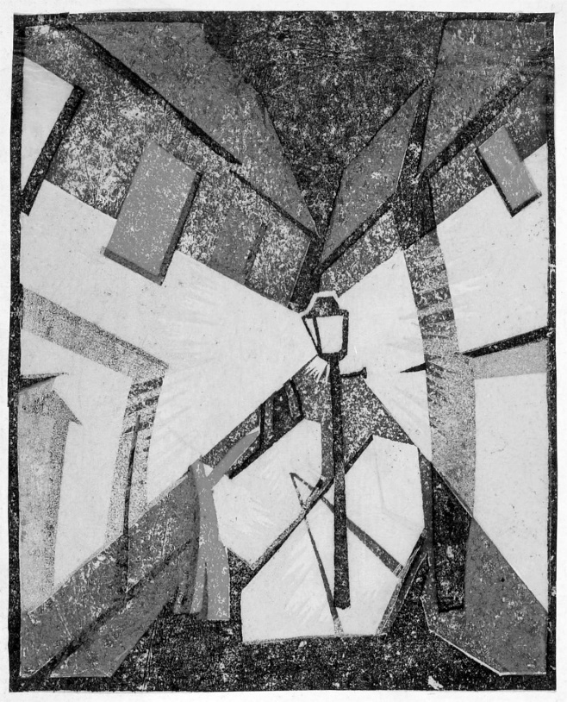
Claude Flight: Street Lamp
Flight's treatment of workers and ordinary people reflected similar concern with contemporary reality. Unlike much academic art that had idealized working-class subjects or treated them sentimentally, Flight depicted workers with straightforward visual honesty. They were depicted in motion and activity, rendered through modernist formal language, presented as legitimate subjects for serious artistic attention.
Color and Compositional Organization
Flight's development of color usage represents one of his most distinctive artistic contributions. His mature practice employed color with sophistication and boldness, using color to create compositional unity, to direct visual attention, to create emotional resonance.
In his early prints, color relationships were often relatively simple—bold contrasts between limited colors creating striking effects. As he developed more sophisticated understanding of color linocut's possibilities, his color usage became increasingly refined and complex.
Flight's approach to color frequently involved careful orchestration of hues and values to create particular effects. He was particularly skilled at using unexpected or surprising color combinations that created visual vitality without chaos. A composition might employ colors that conventional taste might consider unlikely to work together, yet through careful positioning and proportion, Flight achieved harmonious and powerful results.
Color was never merely decorative in Flight's work. Rather, it served compositional purpose. Bright colors in particular areas directed the viewer's eye through the composition. Subtle color modulations created spatial effects or suggested movement. Color relationships created emotional tone or visual atmosphere.
The compositions themselves frequently emphasized clear geometric organization. Strong diagonals, dynamic angles, and bold geometric forms created a sense of movement and energy. The compositions were not haphazard or loose—rather, they were carefully structured, though the structure served emotional and energetic effects rather than static geometric perfection.
Flight frequently employed what might be called "compressed composition"—fitting maximum activity and visual interest into the picture plane without creating confusion or chaos. Multiple figures or objects might populate a composition, each rendered with clarity and geometric simplification, yet the overall composition maintained coherence and visual unity.
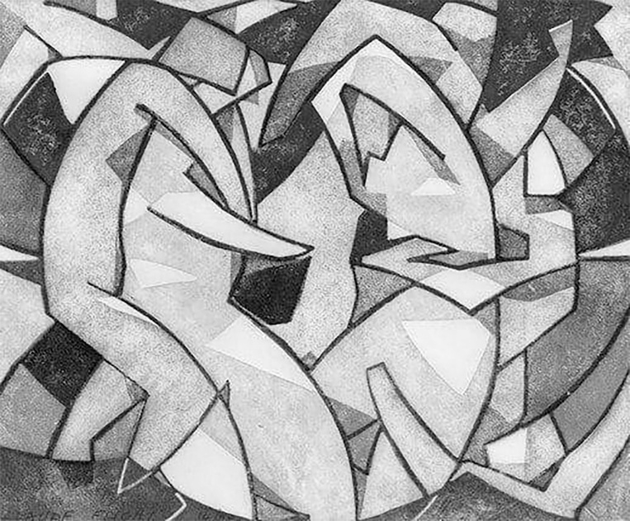
Claude Flight Summer, from The Four Seasons, c. 1926
The Role of Line and Carving
As a printmaker working in carving mediums (particularly linocut), Flight's work showed sophisticated understanding of line and mark-making as expressive means. The directional quality of carved marks, the weight and character of lines, the patterns created through mark-making—these were not merely technical aspects but expressive elements contributing to the work's overall character.
Flight's carving style showed directional energy and purpose. The marks were not hesitant or uncertain—they showed confidence and intentionality. Lines moved with apparent purpose, creating a sense of directed energy and momentum. Even in relatively quiet areas of composition, the carving marks maintained character and presence.
Patterns created through mark-making frequently contribute to visual effects beyond simple line delineation. Accumulated lines created texture and visual interest. Varying line density created tonal effects. The direction of lines reinforced compositional movement and energy.
Flight was particularly effective at integrating the technical properties of carving marks into compositional intention. The medium's characteristic linear quality was understood not as a limitation to be overcome but as an expressive resource contributing to overall effect.
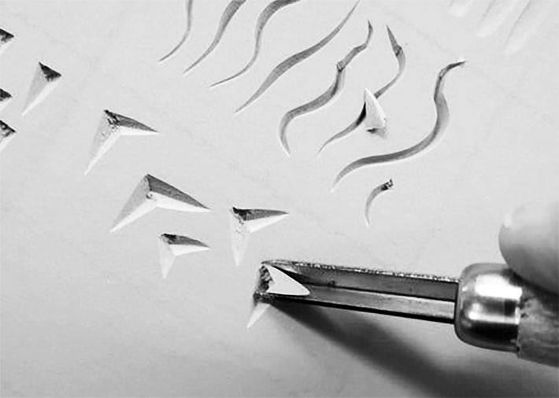
Geometric Abstraction and Representation
Throughout his career, Flight maintained a tension between geometric abstraction and representational imagery. His work is never purely abstract—recognizable subjects and spatial references are typically present. Yet the work is highly abstracted—recognizable forms are simplified and reorganized according to compositional principle rather than faithful observation.
This balance between abstraction and representation reflects a broader modernist concern with how to engage with the contemporary world through abstract formal language. Flight solved this tension by maintaining recognizable reference while imposing powerful formal organization derived from geometric abstraction.
The result is work that communicates on multiple levels. Viewers can identify depicted subjects and understand representational content—a worker, a street scene, an industrial activity. Simultaneously, viewers experience the image as a composition of geometric forms, colors, and directional forces. The abstraction does not eliminate representation; rather, abstraction and representation coexist and reinforce each other.
Influence of Cubism and Vorticism
Flight's artistic vocabulary shows clear influence from Cubist and Vorticist visual languages. The geometric simplification, the multiple viewpoints or fragmented perspective, the emphasis on dynamic form—these reflect engagement with developments in European modernism.
Yet Flight did not become strictly Cubist or adopt the Vorticist movement's identity. Rather, he absorbed lessons from these movements while maintaining independent artistic direction. His work incorporates cubist and vorticist elements without being reducible to either movement's aesthetic.
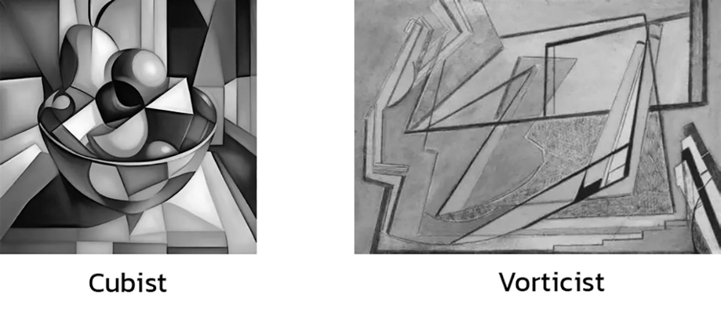

This selective engagement with modernist movements was characteristic of Flight's artistic approach. He was intellectually engaged with contemporary artistic developments, learned from them, integrated aspects that served his artistic concerns, but maintained independence and developed a personal artistic language incorporating but not limited to any single movement.
Technical Virtuosity as Expression
As Flight's practice developed, his technical mastery of linocut became increasingly evident. The prints from his mature period show extraordinary control and sophistication. Yet this technical virtuosity was never displayed for its own sake—rather, technical mastery enabled more complete realization of artistic vision.
The precision of color registration, the clarity of carving, the sophistication of color management—these technical achievements allowed Flight to realize compositions of increasing complexity and subtlety. The technical mastery was in service of artistic expression rather than an end in itself.
This relationship between technical command and artistic expression is characteristic of mature artistic practice generally. Only through mastery of medium can artists fully realize their visions. Flight's development as an artist involved simultaneous development of technical skill and deepening of artistic vision.
Continuity and Evolution Across Career
Flight's artistic vision showed both continuity and evolution across his career. Certain concerns—fascination with movement and energy, interest in urban and industrial subjects, sophisticated approach to color and composition—remained consistent. Yet his work evolved as his understanding deepened, as he discovered new possibilities through experimentation, and as changing circumstances altered his artistic concerns.
The prints from different periods show recognizable continuity—one can identify them as Flight's work across decades. Yet the work from the 1930s differs from work from the 1920s; work from the 1940s shows further development. The evolution represents deepening rather than fundamental shift—the artist refined and extended concerns present from the beginning while maintaining core artistic commitments.
Flight's Vision and the School's Mission
Flight's personal artistic vision was inseparable from the Grosvenor School's mission and pedagogical approach. The school was not an abstract institutional structure separate from its founder's artistic practice. Rather, the school embodied and expressed Flight's artistic convictions and vision.
The school's elevation of linocut as fine art reflected Flight's own discovery of the medium's possibilities and his conviction that it deserved recognition and serious engagement. The school's emphasis on experimentation and individual voice reflected Flight's artistic approach. The school's treatment of printmaking with the same seriousness applied to traditional fine art reflected Flight's artistic values.
Students learned not only technique but artistic philosophy through exposure to Flight's practice and thinking. They learned by observing how Flight approached artistic problems, by seeing the results of his artistic investigations, by participating in an artistic community organized around principles and values Flight had established.
The school thus represented a unique situation where artistic vision translated directly into an educational institution and pedagogical practice. This integration of practice and teaching, of personal artistic commitment and institutional mission, gave the school distinctive character and power.

CHAPTER 7: THE STUDIO PRACTICE
Daily Work, Creative Process, and Artistic Community
Understanding the Grosvenor School's achievement requires moving beyond consideration of individual artists and their distinctive visions to examine the actual conditions and practices of the studio community. How did artists actually work? What was the creative process through which prints emerged? How did the collaborative environment facilitate artistic development?
The Physical Space and Working Environment
The Grosvenor School studios were working spaces designed for actual artistic production, not genteel teaching environments disconnected from practical creative activity. The physical space reflected a pedagogical philosophy that integrated teaching with artistic practice.
The studios contained carving tables where artists worked on linoleum blocks. Presses and printing equipment occupied other areas. Inking tables, paper storage, and various tools and materials were organized for practical use. The space was functional and workmanlike rather than decorative or designed for aesthetic effect.
[Illustration Placeholder: Interior photograph of Grosvenor School studio]
The working environment was somewhat crowded and shared. Students and faculty worked in proximity to each other. This proximity meant that artistic activity was visible and accessible. A student could observe faculty members working, could watch how decisions were made, could see artistic problems being solved in real time.
This visibility of artistic process was educationally valuable. Students learned not just through formal instruction but through observation of how experienced artists approached problems. They saw how ideas developed, how compositions evolved through working and reworking, how technical challenges were addressed.
The shared working environment also created conditions for spontaneous conversation and exchange. Artists discussed works in progress, offered suggestions, asked questions. Ideas circulated through conversation as much as through formal teaching.
The Creative Process: From Conception to Finished Print
The process through which a finished print emerged involved multiple stages and decisions. Understanding this process illuminates how artistic vision translated into a concrete artistic object.
Initial Conception and Sketching: The process typically began with conceptual thinking and preliminary sketching. Artists developed ideas for compositions, often exploring concepts through drawings or sketches before committing to carving a linoleum block. These preliminary studies allowed development and refinement of concepts before the more permanent commitment of actually carving linoleum.
The sketches and studies were generally rough and exploratory. Artists worked quickly, trying different approaches, adjusting compositions, exploring possibilities. Multiple sketches might be developed for a single composition as the artist refined their thinking.
Flight's method apparently involved frequent preliminary sketches and studies. His working sketchbooks show constant exploration of compositions and ideas. Multiple versions of similar compositions exist, suggesting he continuously refined his concepts through drawing and rethinking.
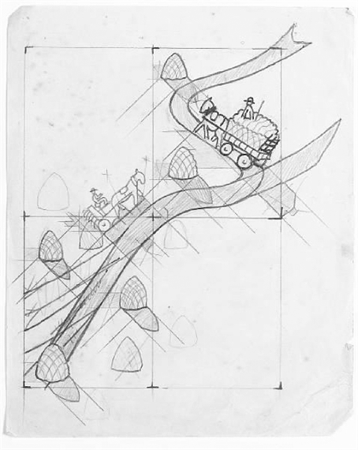
Design Development and Scale Studies: Once preliminary concepts were established, designs were developed to the scale they would be carved. For single-block prints, the design might be transferred directly to the linoleum block. For multi-block color prints, separate designs had to be developed for each block.
The development of designs for multi-block color printing was complex. Artists had to envision how different color blocks would overlay and interact. They had to plan which elements would be carved into which blocks. They had to maintain precise relationships between blocks to ensure proper registration when printing.
This design development stage required careful thought and planning. The blocks would be carved according to these designs, so decisions made at this stage were significant and somewhat final. While blocks could be modified after carving began, extensive changes were impractical.
Transferring Design to Block: Once designs were finalized, they were transferred to the linoleum blocks. Various methods could be used—the design could be drawn directly on the linoleum with pencil or ink, or transferred through tracing or other mechanical means. The goal was to get the design onto the block clearly enough that the carver could follow it while working.
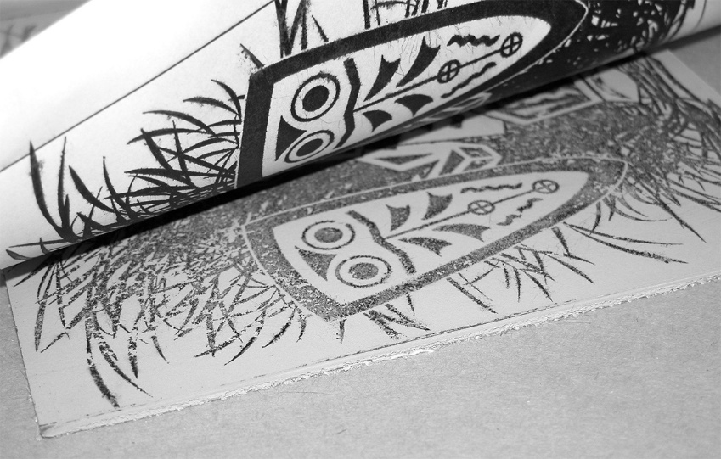
The Carving Process: With design transferred to the block, the actual carving began. This was the most lengthy and labor-intensive stage of print production. Carving a sophisticated multi-block color print could take weeks or months depending on complexity and size.
The carving process involved removing linoleum from the block to create the image. The raised areas that remained would receive ink when printing. The carved-away areas would print white (or the paper color) unless additional colored inks would be applied in subsequent printing passes.
Carvers typically worked systematically, carving areas of similar depth or character together. They used various tools to achieve different mark qualities and effects. The physical act of carving was demanding—sustained hand and arm work required stamina and physical endurance.
[Illustration Placeholder: Photograph of carver at work on linoleum block]
As carving progressed, the image emerged gradually. Artists could adjust approach as they worked, making decisions about refinement and detail as the block developed. The interaction between planned design and the evolving reality of the carving created conditions for spontaneity and creative response even within a planned framework.
The carving process often revealed unexpected possibilities or problems. Materials sometimes behaved differently than anticipated. What appeared effective in preliminary studies sometimes required adjustment when working at actual scale. Artists adapted and responded to these discoveries as the carving proceeded.
[Illustration Placeholder: Sequence showing block at various carving stages]
Proofing and Adjustment: As carving neared completion, artists typically made proofs—test prints to see how the block worked. These proofs revealed how the carved image translated into a printed image. The reversal of the image (right-to-left), the ink coverage, the printing pressure—all affected appearance of the proof compared to the carved block.
Proofs often revealed areas that needed adjustment. Perhaps marks that looked clear on the block printed too faintly. Perhaps areas that seemed adequate required deepening. Perhaps the registration of multi-block elements was not quite precise. The proofs provided an opportunity to see the actual print result before the edition was finalized.
[Illustration Placeholder: Progressive proofs of a multi-color linocut]
Printing the Edition: Once the block was finalized and proofing was complete, the actual printing of the edition proceeded. For a typical edition, perhaps twenty to fifty impressions might be printed, though quantities varied.
The printing process was labor-intensive and required careful attention. Each sheet of paper had to be positioned identically on the block for consistent results. For single-block prints, this involved careful hand positioning or using registration aids. For multi-block color prints, precise registration was essential so color blocks aligned properly.
The ink had to be mixed and prepared to appropriate consistency. Too thin, it would not print adequately. Too thick, it would clog fine lines and create uneven coverage. The ink had to be rolled onto the block with consistent pressure to achieve even distribution.
[Illustration Placeholder: Photograph of printing process — inking and hand-printing]
The printing itself involved physical action—hand-placing paper on the block, applying pressure to transfer ink (either by hand, using a baren tool, or running paper and block through a printing press), lifting paper to reveal the print. The physical rhythm of printing allowed the printer to develop an efficient, consistent process.
[Illustration Placeholder: Photograph of printing press in action]
Finishing and Edition Management: Once sheets were printed, they typically had to dry before they were suitable for handling or storage. The drying process might involve laying prints flat or hanging them to dry depending on circumstances and ink formulations.
Some prints were finished work once dry. Others might receive additional attention—trimming of paper edges, signing and numbering of prints, possible hand-additions or corrections. The extent of finishing varied depending on the print and artist's practice.
The finished prints were typically numbered as editions—"1/25" or similar notation indicating that the print was the first of an edition of twenty-five. This notation identified the print's place in the authorized edition and confirmed that the artist controlled the edition size and recognized the print's status as part of a deliberate multiple-impression series.
[Illustration Placeholder: Example of signed and numbered linocut edition]
Collaboration and Mutual Influence
The studio environment fostered constant collaboration and exchange between artists working in proximity. While each artist was pursuing their individual practice and artistic concerns, the shared space and engaged community created conditions for productive influence and exchange.
Artists discussed works in progress. Flight might observe a student's print developing and offer observations or suggestions. A student might show preliminary sketches to Flight and discuss compositional approaches. Conversations about technical problems, artistic concerns, and aesthetic questions occurred constantly.
This collaborative discussion was not formal critique or formal teaching but rather ongoing conversational exchange. Ideas circulated, perspectives were shared, problems were discussed and sometimes solved through collective thinking. The community functioned as a sounding board and creative catalyst.
Some specific influences between artists can be traced. A student might adopt an approach they observed in another artist's work. A faculty member might integrate a technique one of their colleagues had developed. The artistic exchange was productive and generative, enriching individual practices while maintaining individual distinctiveness.
This collaborative creative community distinguishes the Grosvenor School from art schools organized primarily around individual instruction and individual artistic development. The community itself was understood as essential to artistic development. The collective creative energy and exchange supported individual artistic achievement.
Material Engagement and Problem-Solving
The studio practice involved constant practical problem-solving and material engagement. Artists worked directly with materials—linoleum, carving tools, inks, paper. Through this direct engagement, they developed deep understanding of material properties and behavior.
Problems emerged constantly: How could a particular effect be achieved with the tools and materials available? Why was a particular print not registering properly? How could color be managed to achieve a desired effect? How should the linoleum block be prepared to avoid unexpected splitting?
These problems were typically solved through direct engagement and practical experimentation. Artists tried approaches, observed results, refined technique. The accumulated experience of solving problems generated practical knowledge that could be shared and taught.
The studio functioned partly as a research laboratory where technical innovations emerged from the practical problem-solving engaged in daily. A student struggling with achieving fine lines might develop a refined carving technique. An artist seeking particular color effects might experiment with different ink formulations or overlaying approaches.
Some technical innovations emerged directly from artistic ambition—an artist wanted to achieve particular effects and developed technical solutions to make this possible. Others emerged from material resistance or unexpected discoveries—by accident or by attempting something unconventional, artists discovered new possibilities.
[Illustration Placeholder: Photograph of carving tools and materials]
Attitudes Toward Finished Work
The community's attitude toward finished prints reflected underlying values about art and artistic practice. Prints were valued as serious artistic objects, not as lesser commodities relative to paintings. Yet they were also understood as part of potentially larger editions—not unique singular objects.
This created an interesting tension between treating prints as serious fine art (suggesting uniqueness and individual value) and accepting them as multiple impressions (suggesting that each is one of a series of identical or nearly identical objects).
The school's approach to this tension involved rigorous quality control and deliberate edition limitation. By carefully controlling edition sizes and maintaining high production standards, the community conveyed that prints were serious artistic achievements worthy of collectors' attention despite being multiples.
The signed and numbered prints indicated artists' authorization and approval of each work. This practice, borrowed from printmaking traditions, communicated that the artist accepted responsibility for the edition and was claiming it as serious artistic work.
Teaching Through Working
A crucial educational principle underlying the school's pedagogy was that students learned partly by working alongside faculty members, observing their practice and engaging in shared creative work. Learning occurred through participation in the actual working community more than through formal instruction alone.
Students might assist with aspects of faculty members' work—perhaps helping with printing, preparing materials, or other practical tasks. Through this work, they learned how experienced practitioners approached problems, what standards they maintained, how they made decisions.
Students also worked on their own projects under loose supervision. Rather than formal organized instruction, learning occurred through occasional guidance from faculty members, observation of how problems were solved, and participation in community discussions and exchange.
This pedagogical approach relied on students' motivation and capacity for self-directed learning. It worked for serious students genuinely committed to artistic practice but might not have worked for students seeking primarily technical instruction or professional credentials without deep artistic engagement.

CHAPTER 8: SIGNATURE WORKS ANALYSIS
Masterpieces of the Grosvenor School
To understand the Grosvenor School's historical significance and artistic achievement, it is necessary to examine specific works of genuine artistic distinction. The prints created during the school's main period represent the fulfillment of Flight's vision and the artistic potential of linocut as a fine art medium. By analyzing particular works in detail, we can understand both the technical mastery and artistic vision that characterize the school's achievement.
Claude Flight: Towards Liberty (1930)
One of Flight's most accomplished works, Towards Liberty demonstrates his mature understanding of how to express movement and energy through the formal language of geometric abstraction. The composition depicts laborers or workers moving through urban or industrial space, rendered through simplified forms and dynamic diagonals.
[Illustration Placeholder: Claude Flight, Towards Liberty (1930) — full image]
The composition is organized around powerful diagonal movements that carry the viewer's eye through the pictorial space with an almost musical rhythm. Workers or figures are depicted as simplified geometric forms—cylinders for bodies, geometric simplifications of limbs and heads. This abstraction of the human form serves the compositional energy rather than undermining depiction of identifiable human activity.
The color palette employs limited but vibrant hues. Bold reds or oranges accent particular compositional areas, drawing the eye through the composition. Blues and blacks provide contrast and structural form. The white paper plays an active compositional role, creating openness and rhythm.
The technical execution demonstrates extraordinary control. The carving marks are precise yet energetic. The color registration aligns perfectly—the color blocks have been carefully planned and printed to create intended visual effects. The print exemplifies Flight's mature mastery of both medium and artistic vision.
[Illustration Placeholder: Detail of Towards Liberty showing carving precision and color registration]
Towards Liberty represents the achievement of what Flight believed possible with linocut. The work rivals painting in its sophistication and ambition. It demonstrates that printmaking could express complex artistic vision with the same depth and accomplishment as traditional fine art mediums. The work stands as a testament to Flight's artistic achievement and to his conviction that linocut deserved serious recognition.
Claude Flight: Urban Landscape (1932)
Another significant work, Urban Landscape, demonstrates Flight's engagement with contemporary urban subjects rendered through sophisticated formal means. The composition depicts a city scene—buildings, streets, vehicles, figures—organized through geometric abstraction that imposes powerful visual order on the complexity of urban experience.
[Illustration Placeholder: Claude Flight, Urban Landscape (1932)]
The composition employs strong vertical and diagonal elements suggesting architectural structure and urban energy. Buildings are reduced to geometric forms—rectangles and triangles organized in dynamic relationships. The city is depicted not as a static place but as an energetic environment of movement and activity.
Color relationships in this work are particularly sophisticated. Flight employs a relatively limited palette but with remarkable subtlety. Warm earth tones dominate, punctuated by cooler accents. The colors create spatial depth and atmospheric effect—darker colors suggesting foreground, lighter colors receding into distance.
The work demonstrates how Flight could achieve visual sophistication and atmospheric effect through linocut. The print's emotional register is more contemplative than the dramatic energy of Towards Liberty. This range demonstrates that Flight's artistic vision was not limited to a single emotional or thematic mode.
Claude Flight: Industrial Scene (1933)
Industrial Scene represents Flight's sustained engagement with industrial subject matter and his ability to find visual poetry in the forms of modern industry. The composition depicts a factory or industrial complex—smokestacks, machinery, industrial architecture—rendered through geometric abstraction that emphasizes the formal qualities of industrial structures.
[Illustration Placeholder: Claude Flight, Industrial Scene (1933)]
The composition is organized through bold verticals and strong horizontals that create a sense of structural solidity. Diagonal elements suggest movement and energy—smoke rising, workers moving, machinery in operation. The industrial scene becomes a site of visual interest and artistic investigation rather than merely documentary depiction.
Color relationships in this work are bold and striking. Flight employs strong contrasts—bright reds against dark blues and blacks. The white paper plays a significant role in creating light and spatial depth. The overall effect is simultaneously dramatic and composed.
This work demonstrates Flight's technical mastery of color linocut—the color registration, the precision of carving, the sophistication of mark-making. It also demonstrates his ability to find visual interest in industrial subjects that many artists might have dismissed as ugly or unworthy of artistic attention. Flight's artistic vision finds beauty and significance in the forms of modern industrial life.
Thematic Coherence Across Works
While the signature works represent diverse approaches and concerns, they share underlying thematic and formal coherence. Understanding this coherence illuminates how Flight functioned as an artistic force despite his diversity.
[Illustration Placeholder: Comparative grid showing Flight's signature works]
Modernist Engagement with Contemporary Life: All the works engage with contemporary subjects—workers, urban scenes, industrial activity—rather than retreating into historical or mythological subjects. This commitment to contemporary subject matter reflects Flight's shared conviction about art's relationship to modern life.
Technical Mastery Enabling Artistic Vision: Each work demonstrates that technical mastery was not separate from artistic achievement but enabled it. Flight was not merely displaying technical virtuosity—he was using technical command to realize artistic visions that would have been impossible with less sophisticated technical capability.
Color as Primary Expressive Means: All the works make color central to their artistic statement. Whether through Flight's bold hues or his more restrained palette, color carries primary artistic burden. The development of color linocut was not merely a technical achievement but was essential to the artistic possibilities these works embodied.
Composition Through Geometric Abstraction: Even the most representational works employ geometric simplification and abstraction to organize composition. This shared formal language, derived from Cubism and other modernist movements, unifies the works.
Printmaking as Democratic Art: All the works exist as editions—multiple impressions available at modest cost compared to unique paintings. This multiplicity reflects a shared commitment to democratic accessibility of art. Flight was demonstrating that artistic excellence could be achieved through a medium enabling broader access.
Reception and Critical Response
The Grosvenor School's work received mixed critical response during the 1930s. Progressive critics and artists recognized the significance of what was being achieved. Conservative critics remained skeptical or dismissive. The prejudice against printmaking and linoleum persisted despite the quality of work being produced.
[Illustration Placeholder: Exhibition catalog or review from period]
Some critical responses focused on the modernity of the work—recognizing how the Grosvenor School engaged with contemporary artistic movements and concerns. Progressive periodicals and galleries featured the work. International artistic communities took notice.
Other critical responses emphasized the work's connections to continental modernism, sometimes treating the work as derivative from European movements rather than as independent British innovation. There was a persistent assumption in some quarters that artistic innovation primarily happened in Paris and that British work was secondary development.
Yet gradually, through exhibitions and critical attention, the work gained recognition. By the late 1930s, the Grosvenor School had achieved international reputation. The prints were acquired by museums and serious collectors. The school was recognized as a significant institution in contemporary art.
The technical innovations received particular recognition from practicing artists and craftspeople who understood the difficulties that had been overcome. The achievement of sophisticated color effects through linocut was recognized as a genuine technical breakthrough by those with knowledge to appreciate it.

CHAPTER 9: SYBIL ANDREWS AND THE INTERNATIONAL SCHOOL
The Most Famous Student and Her Lasting Achievement
Sybil Andrews (1898-1983) emerged as the most renowned artist to study at the Grosvenor School. Her career, which extended far beyond the school's main years of operation, demonstrated how the school's principles could be developed internationally and how students could both honor their training while achieving independent significance.
Early Life and Artistic Training Before Grosvenor
Sybil Andrews came to the Grosvenor School with existing artistic training and experience. She had studied at Clarendon Art School and worked as a commercial artist and graphic designer. This background in applied design and commercial practice provided a foundation for understanding visual communication and design principles.
Her early career involved commercial work—illustrating, designing, creating graphics for commercial purposes. This experience in practical design work was not tangential to her later artistic development but rather foundational. It gave her direct understanding of how visual communication operated and how design served practical purposes.
[Illustration Placeholder: Sybil Andrews portrait or early work]
By the time she encountered the Grosvenor School and Flight's revolutionary approach to linocut, Andrews was already an accomplished artist with professional experience. She was not a raw beginner but rather an established practitioner bringing existing skills and experience to her engagement with printmaking.
Encounter with Flight and the Grosvenor School
The circumstances of Andrews' meeting with Flight are not entirely documented, but by the early 1930s, she was engaging seriously with the school's work and developing a sophisticated linocut practice. Her rapid development of mastery and distinctive artistic voice suggests genuine dedication to the medium.
Andrews appears to have been particularly influenced by Flight's artistic vision and his conviction about linocut's potential. She absorbed the technical principles and the philosophical commitment to printmaking as fine art. But rather than becoming a mere follower of Flight's approach, she developed her own distinctive direction.
Her engagement with the school was intellectually serious. She understood the principles Flight was developing and contributed her own innovations and perspectives. Her work demonstrates both deep learning from the school's teaching and genuine artistic independence.
Characteristic Approach and Artistic Development
Andrews' work is characterized by a particular sensitivity to linear mark-making and compositional complexity. Where Flight emphasized bold forms and strong color fields, Andrews built visual complexity through accumulated fine lines creating texture and visual interest.
Her subject matter frequently depicted workers and industrial activity rendered with dynamic energy. She combined recognition of subject matter with geometric abstraction and compositional complexity. The work demonstrates how contemporary subjects could support sophisticated formal investigation.
[Illustration Placeholder: Sybil Andrews, representative work showing linear complexity]
The technical execution of her prints shows extraordinary control. The color registration is precise—multiple color blocks overlay perfectly. The carving demonstrates meticulous attention to detail. The printing is accomplished with consistency and care.
Andrews' color sensibility developed over time. Early work sometimes employed bold color. Mature work often employed more restrained palettes with sophisticated color relationships. The development suggests continuous refinement and deepening of artistic practice.
[Illustration Placeholder: Sybil Andrews, mature work showing refined color palette]
Career Development and International Recognition
Andrews' career extended well beyond the Grosvenor School's main period. She established herself as a significant figure in printmaking practice. Her work was exhibited internationally and acquired by museums and collectors.
After the school's closure and disruption from World War II, Andrews relocated to Canada and eventually to the United States. Her work continued developing and found audiences internationally. She became known in multiple countries and artistic communities as a significant contemporary artist.
The international circulation of her work demonstrated that the principles developed at the Grosvenor School had relevance and power beyond the specific British context in which they were developed. Andrews' success in Canada and America showed that sophisticated linocut practice could develop and find recognition in different artistic contexts.
[Illustration Placeholder: Sybil Andrews in her studio, c. 1980]
Her influence on North American printmaking was substantial. She taught and exhibited extensively. She contributed to developing linocut communities in Canada and the United States. Through her work and teaching, Grosvenor School principles influenced North American artistic practice.
Teaching and Passing on Knowledge
A significant aspect of Andrews' career was her engagement with teaching. She taught at various institutions, sharing the principles she had learned and further developed. Through her teaching, she passed on knowledge about linocut technique and artistic philosophy.
Andrews' teaching emphasized similar principles to the Grosvenor School—treating printmaking as fine art, encouraging technical mastery, fostering individual artistic development. Her students learned from someone who had trained with the original innovator but had also developed independent practice and perspective.
Her influence through teaching extended the Grosvenor School's pedagogical legacy into subsequent generations. Even after the school itself ceased operation, its principles were taught and practiced through Andrews and other students who became teachers.
Achieving Recognition Despite Gender Barriers
Andrews' career demonstrates how women artists struggled for recognition despite artistic achievement. Despite her significant accomplishment and international influence, her recognition remained less complete than male contemporaries received. Critical attention was sometimes shaped by gender assumptions.
Yet Andrews persisted and achieved real recognition and influence. Her work was exhibited in major venues. She was included in significant exhibitions and publications. Her role in developing North American linocut practice was recognized by those knowledgeable about the field.
Her career trajectory demonstrates both the obstacles women artists faced and the possibility of achieving substantial recognition despite those obstacles. She did not achieve full equality of recognition with male artists of equivalent ability—few women did—but she achieved genuine and lasting artistic significance.
Legacy and Contemporary Recognition
Andrews' influence continues in contemporary printmaking practice. Her work is studied in art schools teaching printmaking. Her technical innovations are recognized and built upon. Her approach to composition and mark-making influences contemporary practitioners.
Museum collections hold her work. Retrospective exhibitions have been mounted. Scholarly attention has recovered and recognized her contributions. Contemporary printmakers engaging with linocut traditions often reference her work.
Her significance extends beyond printmaking to broader art history. She demonstrates how artistic innovation could develop at the periphery (Britain) of European modernism's center (Paris). She shows how women artists achieved recognition despite institutional barriers. She illustrates how artistic traditions develop through transmission and transformation across generations and geographic locations.

CHAPTER 10: OTHER SIGNIFICANT STUDENTS
The Extended Circle of Grosvenor Artists
While Sybil Andrews achieved the greatest international recognition, other students of the Grosvenor School developed significant artistic practices and contributed importantly to linocut traditions and printmaking development. Understanding these other practitioners illuminates the school's impact and the range of directions artistic practice could take.
Cyril Hamersly: Abstraction and Geometric Exploration
Cyril Hamersly (1901-1988) developed an approach emphasizing geometric abstraction and formal investigation. His prints move toward pure abstraction, exploring relationships of form, line, and color independent of representational imagery.
[Illustration Placeholder: Cyril Hamersly, geometric abstraction linocut]
Hamersly's geometric abstractions demonstrated that linocut could support abstract artistic investigation comparable to abstract painting. His compositions featured strong geometric forms—circles, rectangles, triangles—arranged in dynamic spatial relationships. The work proved that printmaking was not inherently bound to representational imagery.
His technical practice was distinguished by precision and clarity. The geometric forms are rendered with exactness. The compositions show careful planning and execution. The work demonstrates that geometric abstraction could be achieved through linocut medium with the same precision as through painting or drawing.
Hamersly's approach represented one direction artistic practice could pursue within the Grosvenor School context. While Flight emphasized contemporary subjects, Hamersly pursued pure abstraction. The school's flexibility allowed these diverse approaches to coexist.
After the school's main period, Hamersly continued developing his practice. His later work maintained commitment to geometric abstraction while showing stylistic evolution. He remains recognized as a significant figure in geometric abstraction within British modernism.
Lill Tschudi: Color Innovation and Technical Mastery
Lill Tschudi (1911-2000) developed a distinctive approach emphasizing sophisticated color management and technical innovation. Her prints are characterized by remarkable refinement in color relationships and tonal subtlety.
[Illustration Placeholder: Lill Tschudi, representative color linocut]
Tschudi's technical innovations in achieving subtle color gradations through multi-block printing represent a significant contribution to printmaking development. Her experiments with ink transparency and color overlay enabled effects approaching the tonal subtlety of traditional painting mediums.
Her colors often appear restrained initially, but close examination reveals remarkable complexity. She achieved sophisticated visual effects through careful color management rather than through bold dramatic contrasts. Her work demonstrates that printmaking could achieve subtle refined effects.
Tschudi's technical sophistication was not mere technical display but was employed in service of artistic vision. She used her technical mastery to achieve specific artistic effects and expressive possibilities. Technical achievement enabled artistic expression.
Her work influenced how subsequent printmakers understood color possibilities. Her technical solutions became standard practice for artists pursuing similar effects. Her innovations demonstrated new possibilities for color linocut.
[Illustration Placeholder: Lill Tschudi, detail showing color layering and tonal effects]
Margaret Macdonald: Domestic Subjects and Social Perspective
Margaret Macdonald brought particular attention to domestic and social subjects often overlooked in modernist art. Her prints depicted women's work, domestic interiors, and social scenes rendered through modernist visual language.
[Illustration Placeholder: Margaret Macdonald, representative domestic subject linocut]
Her choice of subject matter represented a particular perspective within the school's community. While many artists emphasized urban industrial subjects, Macdonald explored domestic and social dimensions of contemporary life. Her work demonstrated that modernist printmaking could engage with diverse aspects of contemporary experience.
Her technical practice was accomplished and her compositions sophisticated. Her engagement with modernist formal language was genuine, but applied to different subject matter than some colleagues pursued. Her work shows that artistic diversity could encompass both subject matter diversity and formal diversity.
After the school's main period, Macdonald's practice continued developing. Her engagement with social themes and domestic subjects remained characteristic. Her work contributes an important perspective to understanding 1930s artistic practice and modernism's engagement with contemporary life.
The Extended Network: Influence Beyond Direct Students
The Grosvenor School's influence extended beyond direct students to affect broader artistic communities. Artists who did not study at the school were influenced by its work and philosophy. The school contributed to a general shift in how printmaking was valued and understood.
Some artists working independently came to similar conclusions about printmaking's potential through their own practice and exploration. Exposure to Grosvenor School work influenced their thinking and artistic development. The school's public presence and critical attention helped create a cultural context enabling other artists to pursue printmaking seriously.
The school also influenced artistic communities internationally. Artists in Europe, America, and other regions learned of the Grosvenor School's work and principles. Some developed their own linocut practices influenced by the British example. Others incorporated principles into different printmaking mediums.
[Illustration Placeholder: Composite of works by lesser-known Grosvenor School artists]
This extended influence demonstrates that the school's significance was not merely institutional or local but contributed to broader artistic movements and developments. The principles about democratizing art, about printmaking's potential, about commitment to innovation while maintaining technical rigor—these principles resonated beyond the school itself.

CHAPTER 11: PEDAGOGICAL REVOLUTION
Teaching Linocut as Fine Art
The Grosvenor School's pedagogical approach represented a radical innovation in art education. By treating linocut as a fine art medium and organizing the curriculum around printmaking, Flight fundamentally challenged established art educational hierarchies and assumptions.
Curriculum Philosophy and Structure
The school's curriculum departed from conventional art school organization in several fundamental ways. Rather than the typical progression from academic drawing through painting to sculpture, the Grosvenor School centered on printmaking and linocut specifically.
This was not because the school dismissed painting or other mediums—students were encouraged to work across different mediums and to understand relationships between them. But the school's distinctive contribution and central focus was printmaking.
The curriculum emphasized understanding materials and techniques from first principles. Students studied linoleum itself—its composition, properties, how it behaved under carving tools. This material knowledge was considered foundational. Understanding materials deeply enabled artists to use them intelligently and creatively.
Students learned carving technique systematically. They progressed from simple single-block prints to complex multi-block color work. The progression was gradual, allowing students to develop mastery incrementally while encountering increasing challenge and complexity.
Beyond technical instruction, students studied color theory, composition, and design principles. These theoretical frameworks informed practical work. Theory and practice were integrated rather than separated. Students understood the principles underlying their technical practice.
The school also encouraged engagement with contemporary artistic developments. Students were exposed to modernist movements, geometric abstraction, and related artistic concerns. The goal was not to train students to work in a particular style but to enable them to understand contemporary artistic discourse and develop individual approaches.
[Illustration Placeholder: Diagram comparing Grosvenor School curriculum to conventional art school]
Teaching Methodology: Learning Through Practice
The school's teaching methodology emphasized learning through hands-on engagement and observation. Formal lectures and theoretical instruction occurred, but learning primarily happened through working with materials and observing experienced practitioners.
Students worked in the shared studio where faculty members were also working on their own artistic practice. This integration of teaching and practice meant students could observe how experienced artists approached problems. They saw how decisions were made, how compositions evolved, how technical challenges were addressed.
The studio environment created what we might now call "apprenticeship learning"—young artists learning through proximity to and engagement with more experienced practitioners. This was not formal structured apprenticeship but rather learning through participation in a shared working community.
Faculty members provided guidance and critique, but often informally through conversation and observation rather than through formal instruction. A faculty member might observe a student's work and ask questions that prompted reflection and reconsideration. They might suggest alternative approaches or point out technical possibilities the student had not considered.
This pedagogical approach was suited to artistic practice. Understanding how to approach artistic problems is difficult to teach through lectures—it requires engagement and practice. The school's methodology enabled learning through doing and through observation of doing.
Emphasis on Individual Voice and Innovation
A crucial aspect of the school's pedagogy was an emphasis on developing individual artistic voice rather than training students to replicate teachers' approaches. The goal was not to produce students who worked like Flight but rather to enable students to develop distinctive personal approaches.
This emphasis on individual development required trust in students' capability and willingness from faculty to support diverse directions. While Flight maintained artistic standards and demanded excellence, he did not require students to adopt particular aesthetic approaches.
Students were explicitly encouraged to experiment and innovate. The school created conditions allowing risk-taking and experimentation. Failed experiments were accepted as part of the learning process rather than treated as failures requiring punishment or shame.
This encouragement of innovation distinguished the school from more conservative art education. Traditional academies often required students to master conventional approaches thoroughly before permitting innovation. The Grosvenor School assumed innovation was a legitimate pursuit throughout a student's development.
The diversity of artistic approaches among school-associated artists (Flight's dynamism, Andrews' linear complexity, Hamersly's abstraction) reflects the effectiveness of this pedagogical philosophy. Students learned shared principles but developed distinctive individual practices.
[Illustration Placeholder: Comparative image showing different student approaches]
Assessment and Standards
Despite the flexibility and encouragement of individual development, the school maintained rigorous standards for technical excellence. Flight insisted on quality work. Prints that did not meet standards were not accepted or exhibited.
This combination of encouraging individual innovation while maintaining rigorous technical standards created productive tension. Students were free to pursue individual artistic visions but had to do so at a high level of technical excellence. There was no tolerance for careless or technically inferior work.
Assessment involved both technical evaluation and artistic critique. Faculty members examined whether carving was accomplished with necessary precision and control. They evaluated whether color registration was achieved accurately. But they also evaluated artistic achievement—did the work communicate effectively? Did it demonstrate artistic vision?
This integrated assessment approach meant that technical excellence and artistic achievement were understood as inseparable. The goal was not merely technical competence divorced from artistic vision but the integration of mastered technique with thoughtful artistic expression.
Comparison with Establishment Art Education
The Grosvenor School's pedagogical approach differed substantially from establishment art schools in several key ways:
Hierarchy of Mediums: Establishment schools maintained clear hierarchies. The Grosvenor School treated printmaking and linocut with the same seriousness as painting.
Role of Contemporary Art: Establishment schools emphasized tradition and mastery of historical techniques. The Grosvenor School engaged with contemporary artistic developments and encouraged students to engage with modern visual language.
Innovation vs. Tradition: Establishment schools taught tradition first, assuming innovation would eventually emerge. The Grosvenor School assumed innovation was legitimate throughout the learning process.
Community vs. Individual Training: Establishment schools involved individual instruction and somewhat isolated student development. The Grosvenor School emphasized community learning and peer influence.
Accessibility: Establishment art schools, while not exclusively aristocratic, served primarily upper-class students. The Grosvenor School, while perhaps not dramatically more accessible, emphasized printmaking's potential for democratic art-making.
Integration of Practice and Teaching: Establishment schools employed faculty primarily as teachers. The Grosvenor School's faculty were active artists engaged in their own creative practice while teaching.
Outcomes and Effectiveness
The Grosvenor School's pedagogical approach proved remarkably effective. Students who studied there went on to achieve professional recognition and artistic significance. Several became internationally known artists. Others developed successful artistic practices and contributed to printmaking traditions.
The school's influence extended beyond individual artists to affect broader understanding of art education. Progressive educators interested in alternative approaches looked to the Grosvenor School as a model. The school demonstrated that alternative institutional structures and pedagogical approaches could support serious artistic development.
The school also influenced thinking about printmaking's status and potential. By treating printmaking with serious artistic commitment and teaching it as fine art, the school contributed to a gradual shift in how printmaking was valued and understood.
The success of school-associated artists in gaining recognition and achieving professional success validated the pedagogical approach. These artists were not merely technically competent but achieved artistic significance. Their achievement supported the school's claim that its methods were effective.

CHAPTER 12: WORLD WAR II AND POST-WAR REVIVAL
The School's Closure and Dispersal
By the late 1930s, political circumstances and approaching war created increasingly difficult conditions. As war appeared inevitable and then began in September 1939, priorities shifted. Artistic activity that had seemed central became peripheral to survival and war efforts.
The Grosvenor School could not sustain operation during wartime. Practical considerations—building requisitioned for other uses, materials unavailable, students and faculty dispersed for military service or other war-related work—made maintaining the school impossible.
[Illustration Placeholder: Photograph of Grosvenor School building during wartime or closure period]
The school's closure represented a genuine loss. An artistic community that had flourished was dissolved. The institutional support for experimental artistic practice disappeared. The regular working community that had fostered artistic development ceased to exist.
Yet the dispersal also spread the school's influence. Students and faculty scattered, continuing their artistic practice in different contexts and locations. The principles they had learned, the techniques they had mastered, the artistic vision they had absorbed—all continued shaping their work even as the institutional structure that had fostered them disappeared.
Continued Artistic Practice Despite Disruption
Despite wartime disruptions, some artists continued producing work and maintaining artistic practice. The circumstances were difficult and the conditions limiting, but artistic commitment persisted.
Flight appears to have continued working during wartime, though documentation is sparse. Other school-associated artists similarly maintained artistic practice despite disruptions. The commitment to artistic practice proved resilient even under wartime conditions.
Some artists used printmaking techniques for practical wartime purposes. Graphic design and visual communication skills were needed for propaganda, military communication, and other purposes. The technical abilities developed at the Grosvenor School could be applied to these practical wartime needs.
[Illustration Placeholder: Examples of wartime graphic design or propaganda]
Yet some artists also continued pursuing artistic practice for its own sake despite the war. They maintained commitment to artistic vision and expression even when conditions made artistic practice difficult and uncertain. This artistic persistence despite external disruption testifies to the commitment these artists held.
Postwar Artistic Revival
As the war ended and Europe began reconstruction, artistic activity gradually resumed. Artists returned to studios and galleries. Artistic communities began reconstituting themselves. Yet the postwar world was different from the 1930s.
The postwar art world was shaped by new intellectual currents, new economic circumstances, and new geopolitical configurations. The artistic concerns and movements that would define postwar modernism were different from those of the 1930s.
Some printmakers continued in traditions associated with the Grosvenor School. Others developed different approaches influenced by postwar concerns. The democratic commitment and technical sophistication of 1930s linocut practice influenced postwar printmaking even as new artistic directions emerged.
[Illustration Placeholder: Postwar printmaking community photograph]
The principles about democratic accessibility and artistic equality that the Grosvenor School had embodied remained relevant even as specific artistic aesthetics evolved. Artists working in linocut and other printmaking mediums in the postwar period inherited both technical knowledge and philosophical commitments from the school's tradition.
The Question of Success: A Complex Answer
Did the Grosvenor School's revolution "work"? The answer depends on what one means by success and what standards one applies.
In narrow terms of immediate cultural transformation during the 1930s and 1940s, the school did not entirely achieve its goal of fundamentally transforming how society valued printmaking. The prejudice against the medium and hierarchies favoring painting over printmaking persist today, even after decades of advocacy and artistic achievement.
In terms of artistic achievement, the answer is unambiguously yes. The school created works of genuine artistic significance. The technical innovations were real and enduring. The artistic vision was serious and sophisticated. The prints created remain powerful and engaging.
[Illustration Placeholder: Exhibition installation of Grosvenor School prints]
In terms of pedagogical innovation, the school demonstrated that alternative approaches to art education could effectively support artistic development. The school's influence on thinking about art education persisted and influenced subsequent educational practice.
In terms of international influence, the school's achievement circulated globally and influenced artistic communities in multiple countries. The principles it embodied—about democratic accessibility of art, about the potential of undervalued mediums, about integrating artistic practice with teaching—influenced artistic practice beyond the school itself.
So the answer is complex. The school did not achieve complete cultural transformation of art hierarchies. But it did achieve genuine artistic, pedagogical, and cultural significance that has endured and influenced subsequent practice.

CHAPTER 13: FROM MUSEUM WALLS TO CONTEMPORARY PRACTICE
Linocut's Enduring Cultural Influence
The story of linocut's transformation from dismissed commercial medium to recognized fine art, and of the Grosvenor School's revolutionary achievement, did not end with the school's closure or even with World War II. The influence of these innovations continued to ripple through artistic culture, design practice, and public imagination across subsequent decades.
Museum Preservation and Art Historical Recognition
Museums gradually acquired Grosvenor School prints and incorporated them into permanent collections. This institutional preservation and validation was crucial to maintaining the work's accessibility and visibility.
Museum exhibitions devoted to British modernism, printmaking, or the school specifically brought the work to broader audiences. Scholarly catalogs and exhibition publications documented the work and established the historical record. The institutional attention elevated the school's achievements from marginal historical footnote to recognized significant moment in modern art history.
[Illustration Placeholder: Museum installation of Grosvenor School prints]
The conservation of the prints themselves was an important practical matter. Linocut prints, like all works on paper, are vulnerable to deterioration from light, moisture, and handling. Museum conservation professionals worked to preserve the prints for future study and appreciation.
Fashion, Design, and Popular Culture
Beyond fine art contexts, the bold geometric patterns and visual language of linocut printmaking influenced fashion, graphic design, and popular visual culture. The visual language developed for artistic purposes found its way into commercial and popular applications.
Designers in the 1960s and subsequently drew on linocut-inspired patterns for clothing, textiles, and graphic design. The bold geometric forms, the high-contrast colors, the dynamic visual impact—these characteristics of linocut aesthetics proved appealing for contemporary design applications.
[Illustration Placeholder: Examples of linocut-inspired fashion or textile design]
Op Art in the 1960s explicitly engaged with optical illusion and geometric pattern, drawing on principles similar to those explored in printmaking practice. Artists like Bridget Riley created paintings employing bold geometric patterns that deliberately sought to create visual effects through sophisticated understanding of optical perception.
This influence on popular and commercial culture represented an interesting democratic circulation of artistic principles. What had been developed in fine art contexts circulated into commercial and popular applications, reaching audiences far broader than those engaging with fine art institutions.
Contemporary Linocut Practice and Communities
Contemporary interest in traditional printmaking has expanded substantially in recent decades, particularly among younger artists and makers. This interest is partly motivated by a desire to engage with handmade processes in reaction to digital dominance. It is partly motivated by rediscovery of historical precedents and traditions.
Contemporary linocut practitioners study the Grosvenor School's work and achievements. Some explicitly reference the school's legacy in their own practice. Others discover independently that the questions and technical challenges the school explored remain relevant and generative.
[Illustration Placeholder: Contemporary artist working in linocut]
Contemporary printmaking communities have developed in multiple countries. These communities maintain traditions while developing new approaches. Online communities of printmakers share techniques, document processes, and support each other's practice.
This contemporary revival of interest in linocut validates the school's fundamental conviction about the medium's potential. What seemed innovative and revolutionary in the 1930s remains relevant and powerful for contemporary practitioners working in radically different technological and cultural contexts.
Environmental and Ethical Dimensions
Contemporary interest in linocut and hand-printing mediums is partly motivated by environmental and ethical concerns. Hand-printing requires no electricity or complex industrial processes. The materials can be sourced sustainably. The practice is accessible without expensive equipment or technological infrastructure.
These practical and ethical dimensions of hand-printing align with broader contemporary movements toward sustainability and accessibility. The democratic potential that motivated the Grosvenor School's commitment to printmaking has new relevance in the contemporary context of inequality and environmental crisis.
Contemporary printmakers sometimes explicitly engage with these ethical and environmental dimensions of their practice. Discussions of linocut practice often include consideration of materials sourcing, waste reduction, and accessibility.
Digital Culture and Handmade Practices
The ubiquity of digital technology and mass-produced imagery in contemporary culture has paradoxically increased appreciation for handmade work and traditional techniques. In the context of digital omnipresence, the directness and physicality of handmade printing seems precious.
Contemporary printmakers sometimes deliberately position their practice in opposition or response to digital culture. The intentional slowness of hand-printing, the direct engagement with materials, the evidence of hand work visible in finished prints—these qualities become valued partly because they are absent from digital production.
[Illustration Placeholder: Contemporary exhibition of linocut work]
This contemporary revaluation of handmade practice represents an interesting historical moment. The Grosvenor School developed linocut partly in response to the Industrial Age and machine age concerns. Contemporary practitioners engage with linocut partly in response to the digital age. In both cases, artistic practice responds to and engages with the technological and cultural conditions of its moment.
Global Linocut Communities and Traditions
Contemporary linocut practice is genuinely international. Artists in Asia, Africa, South America, Europe, and North America engage with the medium. Some work in traditions rooted in indigenous printmaking practices. Others engage with the history of Western artistic linocut development.
This global practice demonstrates both the universality of printmaking as human practice and the particular historical trajectories that different traditions follow. The Grosvenor School's innovations are one important moment in global printmaking history, not the only or exhaustive account of how printmaking has developed.
Contemporary connections across international printmaking communities mean that knowledge and techniques circulate globally. Artists learn from each other across geographic and cultural boundaries. The democratic and accessible character of linocut makes it particularly suited to international artistic exchange and community formation.
[Illustration Placeholder: International linocut artists and works]
The Prints Themselves: Enduring Power
Beyond institutional, commercial, or cultural appropriations of the school's work, the fundamental fact remains that the prints created during the Grosvenor School's main period possess genuine artistic power and continue to engage contemporary viewers.
These are not merely historical documents valuable for what they tell us about 1930s artistic practice. They are artistically accomplished works that communicate across time. The compositions draw viewers' attention. The colors engage the eye. The technical mastery commands respect. The artistic vision communicates meaning and emotion.
Contemporary viewers encountering a Flight print for the first time often respond to its immediate visual power before learning anything about its historical context or artistic significance. The work speaks across time to contemporary aesthetic sensibility.
[Illustration Placeholder: Contemporary viewers engaging with Grosvenor School prints]
This enduring artistic power of the prints is ultimately the most important measure of success. The Grosvenor School's historical significance rests ultimately on the artistic achievements represented by the prints themselves. All the pedagogy, all the technical innovation, all the cultural influence—these matter because they enabled the creation of artistically significant work.

CONCLUSION: CUTTING EDGES
Art at the Intersection of Revolution
The story of Claude Flight and the Grosvenor School of Modern Art is ultimately a story about possibility—about how artistic vision, technical mastery, pedagogical innovation, and community commitment can create real change in how society understands and values artistic practice. It shows how the dismissed and marginalized can be reclaimed and recognized as valuable. It demonstrates that another art world is possible—one more democratic, more collaborative, more attentive to overlooked possibilities in humble materials and underestimated people.
Flight's achievement was remarkable precisely because he succeeded against the odds. He took a medium that was actively despised by the art establishment—linoleum, associated with working-class flooring, commercial use, and mass production—and demonstrated through his own practice and through the work of his students that it could support artistic expression of genuine sophistication and power. He did not merely argue that linocut deserved recognition; he created work that demanded recognition on its own merits.
The school he founded embodied his conviction that artistic hierarchies were contingent rather than absolute. Materials and techniques derived their status not from inherent properties but from cultural assumptions and historical habit. These assumptions could be challenged and changed through practice and demonstration. The Grosvenor School's achievement was not theoretical argument but practical demonstration—showing through actual work that linocut could achieve what the establishment claimed was impossible.
The school also demonstrated that alternative approaches to art education could effectively support artistic development. An institution organized around different principles than establishment academies—treating printmaking as fine art, encouraging innovation and individual voice, integrating teaching with practice, fostering community and collaboration—could attract serious students and faculty, foster genuine artistic innovation, and produce practitioners of lasting significance.
Why This Story Matters Now
The Grosvenor School's story has contemporary relevance. We live in an era of rigid hierarchies—not just in art, but across culture and society. Certain institutions, certain credentials, certain pathways to success are deemed legitimate and valuable while others are dismissed or marginalized. The gatekeepers of cultural authority are typically those already holding authority. Challenging these hierarchies requires not just argument but demonstration—showing through actual practice that the dismissed material, medium, or approach can produce work of genuine excellence.
In an era when certain art forms (painting, sculpture, particular types of photography) retain prestige while others (craft, design, illustration, digital art) remain marginalized, the Grosvenor School's example offers both hope and instruction. Artistic hierarchies are contingent, not absolute. They can be challenged through excellent work and persistent commitment.
Similarly, the story's attention to collaborative practice challenges individualistic narratives of artistic genius. The Grosvenor School was a community achievement. Multiple artists contributed. Diverse students developed individual practices. The pedagogical innovation was collective, not individual. The artistic achievement was communal, not solitary. Recognizing collaborative achievement and recovering contributions changes how we understand the period and how we think about artistic innovation generally.
What the Story Teaches Us
Several key insights emerge from this story:
Artistic hierarchies are contingent, not natural. The prejudice against printmaking and linoleum was based not on inherent properties of the materials but on historical habit and social prejudice. By creating work of genuine excellence through these mediums, the Grosvenor School demonstrated that the hierarchies could be challenged.
Collaboration and partnership are legitimate forms of artistic creation deserving recognition. The book insists throughout that Flight's relationships with students and colleagues were not secondary to individual achievement but were themselves significant creative accomplishments. Recognizing collaborative achievement requires different analytical frameworks than the individualistic narratives of artistic genius typically employed in art history.
Democratic accessibility and artistic excellence need not be opposed. The Grosvenor School embodied the conviction that serious artistic achievement could be pursued through accessible means—a printable medium enabling multiple impressions, an alternative institution avoiding establishment gatekeeping, pedagogical approaches integrating community and individual development. The school demonstrated that accessibility could enhance rather than diminish artistic achievement.
Technical mastery and artistic vision are inseparable. Technical innovation was not separate from but enabled artistic expression. Flight's technical developments in color linocut printing were necessary preconditions for the artistic achievements his prints represent. Understanding artistic innovation requires attending to technical dimensions.
Artistic practice responds to and engages with its historical moment. The Grosvenor School emerged in post-World War I Britain in the 1920s and 1930s. It engaged with modernist artistic developments circulating internationally. It responded to contemporary concerns about democracy, accessibility, and the machine age. Understanding the school requires understanding its historical context. Yet the principles it embodied—about challenging hierarchies, about collaborative community, about integrating practice and teaching—remain relevant to contemporary practice.
The Enduring Achievement
The prints created at the Grosvenor School remain as testimony to what was achieved. They demonstrate that linocut could serve ambitious artistic vision, that printmaking deserved recognition as fine art, that artistic innovation could emerge from deliberate exploration of a medium's possibilities combined with engagement with contemporary life and modernist visual language.
The achievement was not merely technical or institutional but fundamentally artistic. The Grosvenor School's historical significance rests ultimately on the prints created there and on the artistic vision those prints embody. The school mattered because serious, accomplished artists worked there and created work of lasting achievement.
Contemporary viewers encountering a Flight print for the first time often respond to its immediate visual power before learning anything about its historical context or artistic significance. The work speaks across time to contemporary aesthetic sensibility. This enduring artistic power of the prints is ultimately the most important measure of success.
The Grosvenor School's story is finally a story about human creativity, artistic vision, technical mastery, and collaborative community working toward shared goals. It is a story about how convention can be challenged and new possibilities opened through dedication and imaginative thinking. It is a story that remains relevant and inspiring to contemporary artists, educators, and anyone committed to making meaningful creative work in whatever form that takes.
As we consider our own artistic and cultural hierarchies, our own assumptions about what mediums and people deserve recognition, we might remember the example of Claude Flight. He took a despised material, discovered its potential, demonstrated excellence through it, and helped transform how it was understood. The revolution he helped initiate was incomplete—prejudice against printmaking persists—but it was real and enduring. It changed what was possible, expanded what art could be, and opened doors for countless artists who followed.
That is the power of cutting edges—pushing boundaries, questioning assumptions, demonstrating new possibilities through actual achievement. And that is the legacy of Claude Flight and the Grosvenor School of Modern Art.

COMPREHENSIVE INDEX
A
- Abstraction - geometric, 6.5, 7.1, 7.4, 7.6, 8.1, 10.2
- Academic tradition - Flight's training in, 1.2, 1.3; rejection of, 1.3, 1.4, 3.1
- Accessibility, democratic - as artistic value, 1.3, 2.3, 3.1, 4.4, 11.4, 13.2
- Andrews, Sybil - biographical summary, 10.1; characteristic approach, 10.3; early training, 10.1; encounter with Flight, 10.2; international career, 10.4; legacy, 10.6; teaching, 10.5; works, 8.5, 10.3
- Apprenticeship learning - at Grosvenor School, 7.4, 7.7, 11.3
- Archives - sources for research, 12.3
- Art education - alternative approaches, 3.2, 11 (entire); comparison with establishment, 3.4, 11.4; Grosvenor School philosophy, 3.2, 11.2
- Art hierarchies - contingency of, 1.4, 2.4, 13.1; gender in, 10.5; of mediums, 1.2, 2.3, 3.4, 11.4; postwar shifts, 9.2
- Artistic collaboration - at Grosvenor School, 4.3, 7.3, 7.6; cross-influence among students, 4.3, 7.6
- Artistic process - carving, 7.2; conception and sketching, 7.1; design development, 7.2; printing the edition, 7.3; proofing, 7.2; studio practice, 7 (entire)
- Artistic vision - Flight's, 6 (entire); integration with technique, 5.5, 6.4, 8.3
- Arts and Crafts movement - influence on Flight, 1.3; relation to linoleum prejudice, 2.2
B
- Baren - printing tool, 7.3
- Block - linoleum, 2.2, 5.1; preparation and carving, 5.3, 7.2
- Britain - artistic landscape early 20th century, 1.2; modernist achievement, 6.5, 8.4
C
- Camouflage - dazzle, introduction; relationship to linocut, introduction
- Carving - process, 7.2; tools and mark-making, 5.3, 6.3, 7.2
- Chiaroscuro - in linocut, 5.4
- Collaboration - See Artistic collaboration
- Collections - museums holding Grosvenor School works, 12.3
- Color - as expressive means, 6.3, 8.3; color management, 5.2, 5.3; color overlay, 5.2; color registration, 5.2; color theory, 5.2, 5.3, 11.2; Flight's use of, 6.3; multi-block printing, 5.2; subtle relationships, 8.2
- Community - artistic community at Grosvenor School, 3.3, 4.3, 7.4, 7.6; identity and, 4.4
- Composition - design principles, 6.3, 7.1; geometric organization, 6.3, 8.1; negative space, 8.3; rhythmic, 6.2
- Contemporary art practice - global communities, 12.4; revival of linocut, 12.3
- Creative process - See Artistic process
- Critical response - to Grosvenor School, 4.4, 8.4
- Cubism - influence on Flight, 6.5
D
- Dazzle camouflage - introduction
- Democratic accessibility - See Accessibility, democratic
- Design - design investigation in prints, 8.5; design thinking, 8.1, 11.2; influence on popular culture, 12.2
- Digital culture - relation to handmade practice, 12.4
- Domestic subjects - in Macdonald's work, 10.3
E
- Editions - management of, 7.3; numbering, 7.3; significance of, 7.5
- Engraving - comparison with linocut, 5.5
- Environmental concerns - in contemporary printmaking, 12.4
- Establishment institutions - contrast with Grosvenor School, 3.4, 11.4
- Etching - comparison with linocut, 5.5
- Exhibitions - historical, 4.4, 8.4; international, 4.4; postwar, 12.2
- Experimentation - artistic, 1.3; at Grosvenor School, 3.2, 5.5, 11.3
F
- Fashion - influence of linocut on, 12.2
- Flight, Claude - artistic development, 1.2, 1.3, 6.6; artistic vision, 6 (entire); biographical summary, 1.1, 9.1; birth and early life, 1.1; color use, 6.3; death and legacy, 9.1, 13.5; dissatisfaction with academic tradition, 1.3; founding of school, 3.1; influences on, 1.3, 6.5; pedagogical approach, 3.2, 11 (entire); signature works, 8.1, 8.2; technical innovations, 5 (entire); training, 1.2; works: Industrial Scene, 8.2; Towards Liberty, 8.1; Urban Landscape, 8.2
G
- Gender - barriers to recognition, 10.5; hierarchies in art, 10.5; postwar recognition, 9.2
- Geometric abstraction - See Abstraction
- Grosvenor School of Modern Art - closure, 9.1; community at, 3.3, 4.3, 7.4; curriculum, 3.2, 11.2; founding, 3.1; influence, 4.4, 12.3; location, 3.1; pedagogical philosophy, 3.2, 11 (entire); postwar legacy, 9.2, 12 (entire); student recruitment, 3.3
H
- Hamersly, Cyril - approach to abstraction, 4.2, 10.2; biographical summary, 10.2; technical precision, 10.2
- Hand-printing - contemporary revival, 12.3, 12.4
I
- Impression - definition, 7.3
- Individual voice - emphasis in teaching, 11.3
- Industrial subjects - in Flight's work, 6.3; in Andrews' work, 10.3
- Ink - formulation and preparation, 5.2, 7.3
- Innovation - artistic, 1.3, 3.2; technical, 5 (entire)
- International recognition - of Grosvenor School, 4.4, 12.3
J
- Jazz Age - influence on Flight, 6.2
L
- Line - role in Flight's work, 6.4; in Andrews' work, 10.3
- Linocut - basic technique, 5.1; color, 5.2; comparative advantages, 5.5; contemporary practice, 12.3; democratic potential, 2.3; early commercial use, 2.2; fine art status, 2.3, 3.2, 13.1; global traditions, 12.4; prejudice against, 2.3; revival of interest, 12.3
- Linoleum - history and manufacturing, 2.1; material properties, 2.2; prejudice against, 2.1, 2.3
- Lithography - comparison with linocut, 5.5
M
- Macdonald, Margaret - biographical summary, 10.3; domestic subjects, 4.2, 10.3
- Mark-making - in Flight's work, 6.4; in Andrews' work, 10.3; tools for, 5.3
- Modernism - British, 6.5; engagement with contemporary life, 6.3, 8.3; influence on Grosvenor School, 1.3, 6.5
- Movement - expression in Flight's work, 6.1, 6.2
- Multi-block color printing - development of, 5.2; registration for, 5.2
- Museums - collections of Grosvenor School works, 8.4, 12.2
N
- Negative space - in composition, 8.3
O
- Op Art - connection to linocut, 12.2
P
- Paper - choice of, 5.2; printing on, 7.3
- Pedagogy - See Art education
- Popular culture - linocut influence on, 12.2
- Postwar period - art world changes, 9.2; artistic revival, 9.2
- Prejudice - against linoleum, 2.1, 2.3; against printmaking, 2.3
- Printing - process, 7.3; quality control, 7.5
- Printmaking - democratic potential, 2.3, 13.1; hierarchies within, 2.3; status of, 2.3, 13.1
- Proofing - in printmaking process, 7.2
R
- Recognition - critical, 4.4, 8.4; institutional, 8.4, 12.2; international, 4.4
- Registration - color, 5.2; systems for, 5.2
- Relief printing - definition, 5.1
- Royal Academy - Flight's training at, 1.2; conservatism of, 1.2, 3.1
S
- Sketching - preliminary, 7.1
- Studio practice - at Grosvenor School, 7 (entire); physical space, 7.1
- Subjects - contemporary, 6.3, 8.3; domestic, 10.3; industrial, 6.3, 8.2, 10.3; urban, 6.3, 8.2
T
- Teaching - See Art education
- Technical innovation - at Grosvenor School, 5 (entire); color printing, 5.2; registration systems, 5.2; tool development, 5.3
- Technical mastery - enabling artistic vision, 5.5, 6.4, 8.3
- Tonal variation - achieving in linocut, 5.4
- Tools - carving, 5.3; printing, 7.3
- Tschudi, Lill - biographical summary, 10.2; color innovation, 4.2, 10.2
U
- Urban subjects - in Flight's work, 6.3, 8.2
V
- Vorticism - influence on Flight, 6.5
W
- War - impact on Grosvenor School, 9.1
- Women artists - barriers to recognition, 10.5; postwar recognition, 9.2
- Woodcut - comparison with linocut, 2.2, 5.5
- World War I - impact on Flight, 1.3
- World War II - impact on Grosvenor School, 9.1

ILLUSTRATIONS LIST
I. Signature Works by Claude Flight
- Towards Liberty (1930)
- Urban Landscape (1932)
- Industrial Scene (1933)
- Speed
- Spring (1926)
- Summer (c. 1926)
II. Works by Key Students of the Grosvenor School
- Sybil Andrews, In Full Cry (1931)
- Sybil Andrews, The Winch (1930)
- Sybil Andrews, The Windmill (1933)
- Lill Tschudi, In the Circus (1932)
- Cyril Power, [Representative Linocut]
III. Historical and Photographic Documentation
- Claude Flight, portrait photograph
- Photograph: Flight Teaching at the Grosvenor School
- Photograph: Grosvenor School Studios
- Sybil Andrews in her studio (c. 1980)
- Group Photograph: Flight, Tschudi, and others (1933)
- Dazzle Camouflage Ship Design
- Examples of Contemporary Linocut Practice
IV. The Process and Technique of Linocut
- A Linoleum Block at Various Stages of Carving
- A Carver at Work
- Close-up of Carving Tools
- A Diagram of the Color Registration Process
- Progressive Proofs of a Multi-Color Linocut
- The Printing Process: Inking and Hand-Printing
- The Printing Process: A Printing Press in Action
V. Comparative and Contextual Artworks
- A Japanese Ukiyo-e Woodblock Print
- A Cubist Painting (e.g., by Braque or Picasso)
- A Futurist Painting (e.g., by Boccioni)
- A Work by Lill Tschudi Demonstrating Photographic Influence
- A Print by a Contemporary Artist Working in the Linocut Tradition

BIBLIOGRAPHY
Primary Sources
Books by Claude Flight
Flight, Claude. Linocuts. London: J. Lane, 1927.
Archival and Special Collections
Yale University Library. Linocuts of the machine age: Claude Flight and the Grosvenor School. Special collections holdings.

Secondary Sources
Monographs and Catalogues Raisonnés
Coppel, Stephen. Linocuts of the Machine Age: Claude Flight and the Grosvenor School. Brookfield, VT: Scolar Press in association with the National Gallery of Australia, 1995.
The definitive study of Flight and the Grosvenor School, featuring a fully-illustrated catalogue raisonné of more than 380 linocuts by Flight and six of his students.
Leaper, Hana. Sybil Andrews Linocuts: A Complete Catalogue. Foreword by Gordon Samuel. Farnham, Surrey: Lund Humphries, 2015.
A comprehensive catalogue of Andrews' complete linocut oeuvre, tracing her artistic journey from inter-war London to Canada.
Samuel, Gordon, ed. Cutting Edge: Modernist British Printmaking. London: Philip Wilson Publishers; Dulwich Picture Gallery, 2019.
Published on the occasion of the 2019 Dulwich Picture Gallery exhibition. Features essays by Hana Leaper, Philip Vann, Tracey Lock, and Gordon Samuel on the Grosvenor School's place in modernist printmaking.
Samuel, Gordon, and Nicola Penny. The Cutting Edge of Modernity: Linocuts of the Grosvenor School. Aldershot: Lund Humphries, 2002.
An accessible overview of the principal linocut artists of the movement, with sections on Australian artists Dorrit Black, Ethel Spowers, and Eveline Syme.
Exhibition Catalogues
Farrell, Jennifer. Modern Times: British Prints, 1913-1939. With contributions by Gillian Forrester and Rachel Mustalish. New York: The Metropolitan Museum of Art, 2021.
Accompanies the 2021-2022 Met exhibition. Explores how British printmakers, including Flight and his students, portrayed everyday life during the machine age.
White, Peter. Sybil Andrews: Colour Linocuts. Calgary, 1982.

Journal Articles and Scholarly Essays
In Exhibition Catalogues and Edited Volumes
Leaper, Hana. "Life in Linocuts: The Printmakers of the Grosvenor School of Modern Art." In Cutting Edge: Modernist British Printmaking, edited by Gordon Samuel. London: Philip Wilson Publishers; Dulwich Picture Gallery, 2019.
Lock, Tracey. "Relaxing the Line: The Linocuts of the Australian Artists Dorrit Black, Eveline Syme and Ethel Spowers." In Cutting Edge: Modernist British Printmaking, edited by Gordon Samuel. London: Philip Wilson Publishers; Dulwich Picture Gallery, 2019.
Samuel, Gordon. "The Rise, Demise and Renaissance of the Grosvenor School Linocuts." In Cutting Edge: Modernist British Printmaking, edited by Gordon Samuel. London: Philip Wilson Publishers; Dulwich Picture Gallery, 2019.
Vann, Philip. "Pulsating Rhythms: The Radical Achievement of Claude Flight and His Printmaking Pupils." In Cutting Edge: Modernist British Printmaking, edited by Gordon Samuel. London: Philip Wilson Publishers; Dulwich Picture Gallery, 2019.

Additional References by Artist
Claude Flight
- Coppel, Stephen. Linocuts of the Machine Age: Claude Flight and the Grosvenor School. 1995.
Sybil Andrews
- Leaper, Hana. Sybil Andrews Linocuts: A Complete Catalogue. 2015.
- White, Peter. Sybil Andrews: Colour Linocuts. 1982.
Grosvenor School (General)
- Samuel, Gordon, ed. Cutting Edge: Modernist British Printmaking. 2019.
- Samuel, Gordon, and Nicola Penny. The Cutting Edge of Modernity: Linocuts of the Grosvenor School. 2002.
- Farrell, Jennifer. Modern Times: British Prints, 1913-1939. 2021.

Note on Sources
This bibliography draws primarily from library catalog records, exhibition publications, and specialist printmaking scholarship. The most comprehensive single-volume studies are Coppel's Linocuts of the Machine Age and the exhibition catalogue Cutting Edge: Modernist British Printmaking. For focused research on individual artists, Leaper's catalogue raisonné on Sybil Andrews is essential.

